Table of Contents Page

1)General Information . . . . . . . . . . . . . . . . . 3

2)System Requirements . . . . . . . . . . . . . . . . . 4

3)How to start up the Solo Crib program . . . . . . . . 5

4)How to maximize the Solo Crib program window . . . . 9

5)The components of the Solo Crib program window . . . 11

6)How to set keyboard focus to a control by using the Tab key . . . . . . . . . . . . . . . . . . . . . . . . 24

7)How to set keyboard focus to a control by using the Arrow keys . . . . . . . . . . . . . . . . . . . . . . 27

8)How to place a Player card in the crib by using the keyboard keys . . . . . . . . . . . . . . . . . . . . . 36

9)How to place a Player card in the crib by using the mouse device . . . . . . . . . . . . . . . . . . . . . 41

10)How to lead a Player card by using the keyboard keys . . . . . . . . . . . . . . . . . . . . . . . . . 45

11)How to lead a Player card by using the mouse device . . . . . . . . . . . . . . . . . . . . . . . . 48

12)How to select the Go button to indicate that the Player contestant is unable to lead a card in the current pegging series . . . . . . . . . . . . . . . . 51

13)The counting of hands at the end of a hand of cribbage . . . . . . . . . . . . . . . . . . . . . . . 55

14)How to select the New Hand button to start a new hand of cribbage . . . . . . . . . . . . . . . . . . . 60

15)How to select the New Game button to start a new game of cribbage . . . . . . . . . . . . . . . . . . . 63

16)How to set the set the display configuration of a card . . . . . . . . . . . . . . . . . . . . . . . . . 66

17)How to set the Stop Action Interval by using the File menu . . . . . . . . . . . . . . . . . . . . . . . 70

18)How to display copyright information about the Solo Crib computer program . . . . . . . . . . . . . . . . . 72

19)How to close the Solo Crib program by using the File menu . . . . . . . . . . . . . . . . . . . . . . . 75

1)General Information

This section of the documentation provides general information about the Solo Crib computer program.

Solo Crib is a computer program that allows you to play the cribbage card game in competition with the strategy of the Solo Crib House contestant.

The Solo Crib computer program controls the cribbage card game strategy of the Solo Crib House contestant.

You control the cribbage card game strategy of the Solo Crib Player contestant.

2)System Requirements

This section of the documentation provides information about the system requirements of the Solo Crib program.

Solo Crib is designed to run on a computer system that provides the following requirements.

A Windows operating system is required. Solo Crib is designed to run on a standard North American version of Windows, manufactured this century.

A keyboard is required. Solo Crib is designed to use a standard North American keyboard.

A monitor is required.

A mouse device is required.

An Internet connection is required only to obtain a copy of the Solo Crib program file from the Matthews Software Incorporated web site, www.matthewssoftware.ca .

Access to local or network storage media is required to save a copy of the Solo Crib program file. If you have saved a copy of the Solo Crib program file to your computer system, you can run the Solo Crib computer program without an Internet connection.

3)How to start up the Solo Crib program

This section of the documentation provides information about how to start up the Solo Crib program.

You can start up the Solo Crib program by following the steps described below.

First, display the Solo Crib program file in Windows Explorer as illustrated below.
The Solo Crib program file
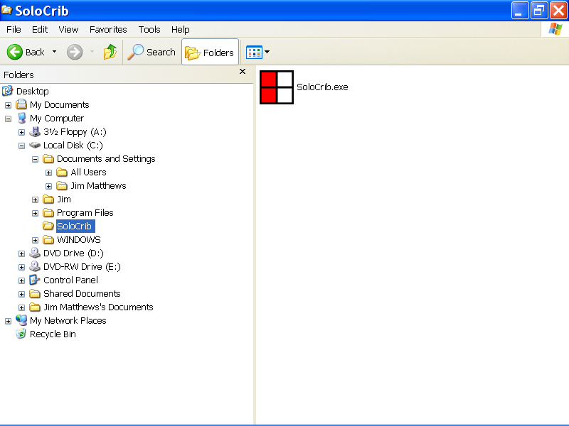

The Windows Explorer program window

After displaying the Solo Crib program file, SoloCrib.exe, in the Windows Explorer program window as described above, select the Solo Crib program file by left clicking the file with the mouse device as shown below.

Then press the Enter key to start up the Solo Crib program.

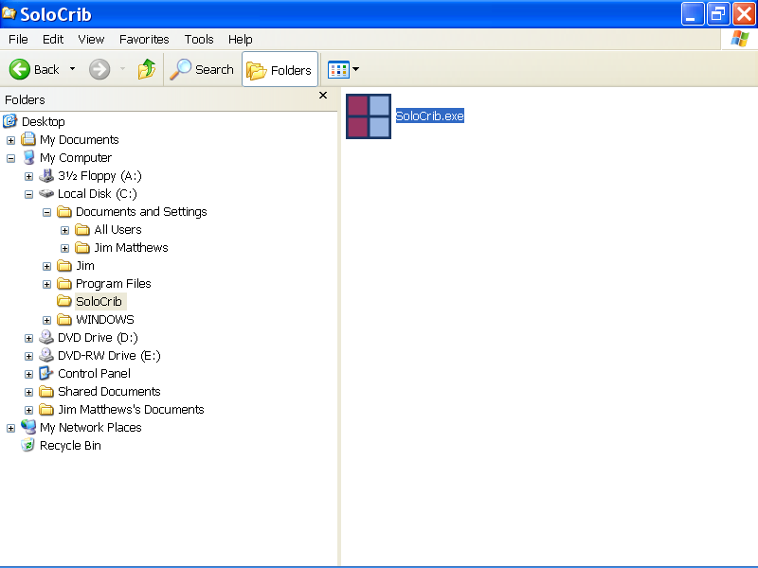

After selecting the Solo Crib program file and pressing the Enter key, as described above, the Solo Crib User Agreement message box is displayed as illustrated below.

If you agree to the terms of the agreement, left click the Yes button with the mouse device.

If you do not agree to the terms of the user agreement, left click the No button with the mouse device.

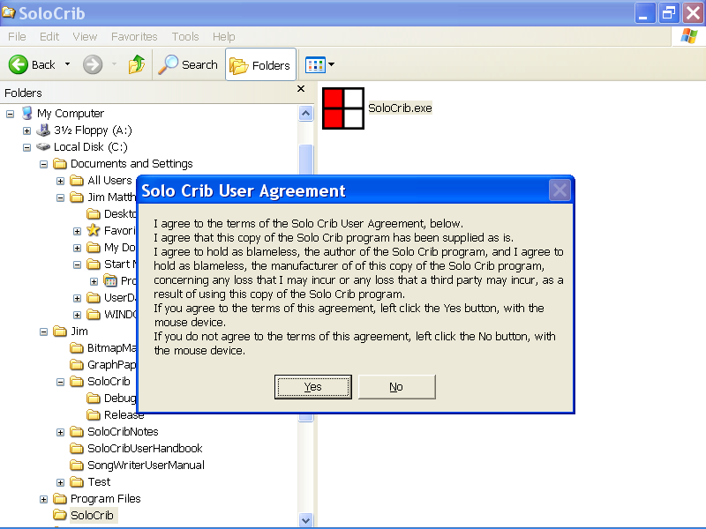

In the illustration below, the Yes button of the Solo Crib User Agreement message box was selected with the mouse device.

The Solo Crib program is now displayed as shown below.

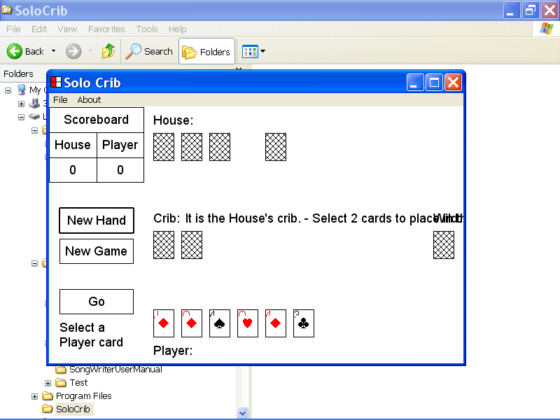

4)How to maximize the Solo Crib program window

This section of the documentation provides information about how to maximize the Solo Crib program window.

You can display the full screen version of the Solo Crib program window, by left clicking the Maximize button with the mouse device.

The Maximize button is located in the upper right corner of the Solo Crib program window, as illustrated below.
The Maximize button

The full screen version of the Solo Crib program is illustrated below.

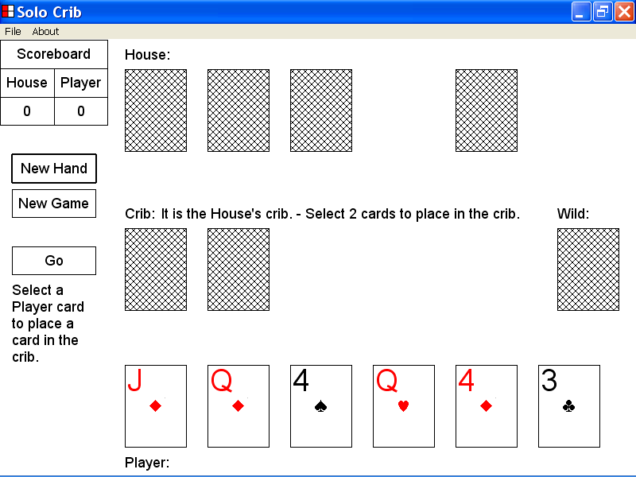

5)The components of the Solo Crib program window

This section of the documentation provides information about the components of the Solo Crib program window.

The components of the Solo Crib program window are the Scoreboard, the New Hand button, the New Game button, the Go button, the Information message box, the House message box, the Crib message box, the Player message box, the House cards, the Crib cards, the Wild card and the Player cards.

The components of the Solo Crib program window are identified with labels in the illustrations below.

The Scoreboard is identified with a label in the illustration of the Solo Crib program window below.

The Scoreboard displays the House score and the Player score for the current game.

In the illustration below, the House score is 2 and the Player score is 0.

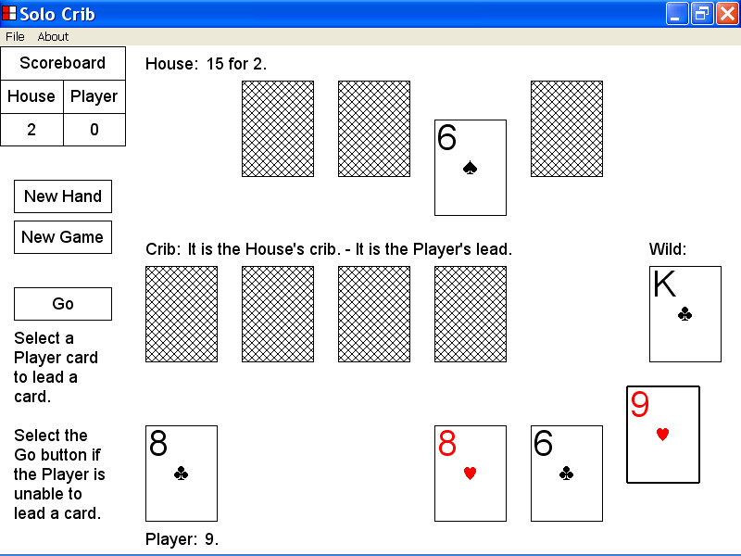
The Scoreboard

The New Hand button is identified with a label in the illustration of the Solo Crib program window below.

You can select the New Hand button to start a new hand of cribbage.

When you start a new hand of cribbage, the House is dealt 6 new cards, the Player is dealt 6 new cards and a new Wild card is dealt by the Solo Crib program.

The current House score and the current Player score are not affected by selecting the New Hand button.

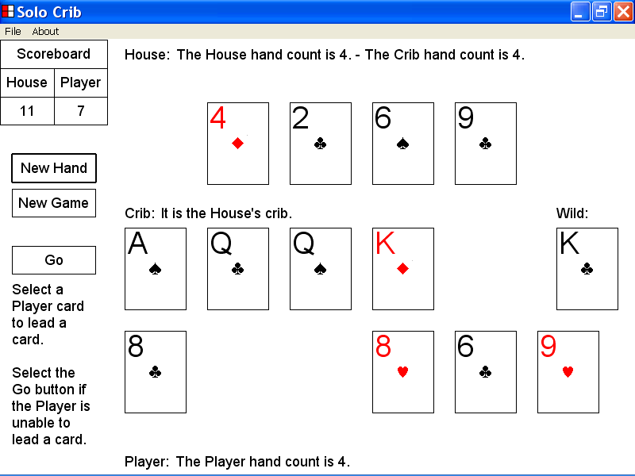
The New Hand button

The New Game button is identified with a label in the illustration of the Solo Crib program window below.

You can select the New Game button to start a new game of cribbage.

When you start a new game of cribbage, the House is dealt 6 new cards, the Player is dealt 6 new cards and a new Wild card is dealt by the Solo Crib program.

The current House score is reset to 0 and the current Player score is reset to 0, when you select the New Game button.

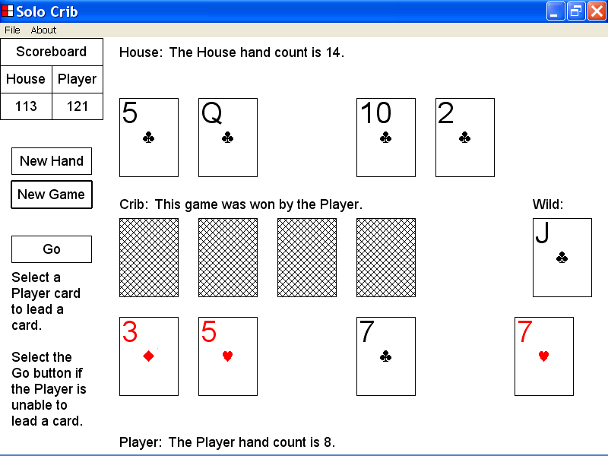
The New Game button

The Go button is identified with a label in the illustration of the Solo Crib program window below.

You can select the Go button to indicate that the Player contestant is unable to lead a card in the current pegging series.

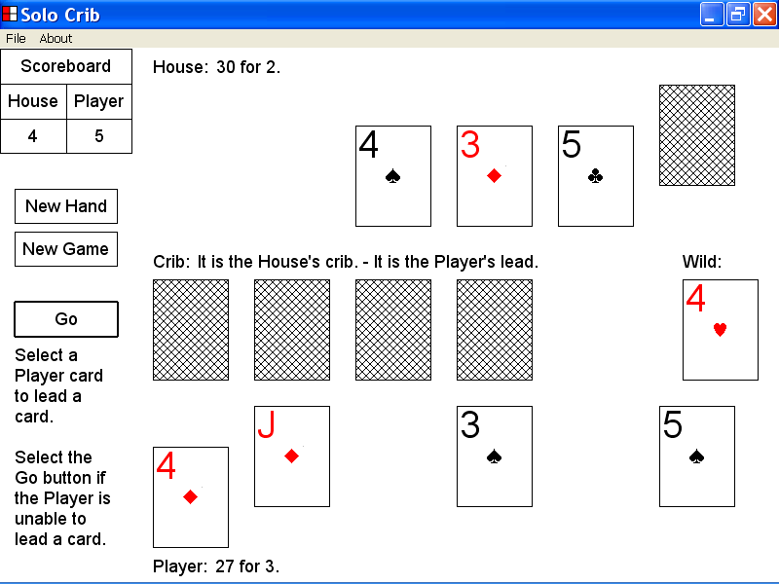
The Go button

The Information message box is identified with a label in the illustration of the Solo Crib program window below.

The Information message box provides information about selecting a Player card and about selecting the Go button.

In the illustration below, the Go button should be selected, as the Player is unable to lead a card.

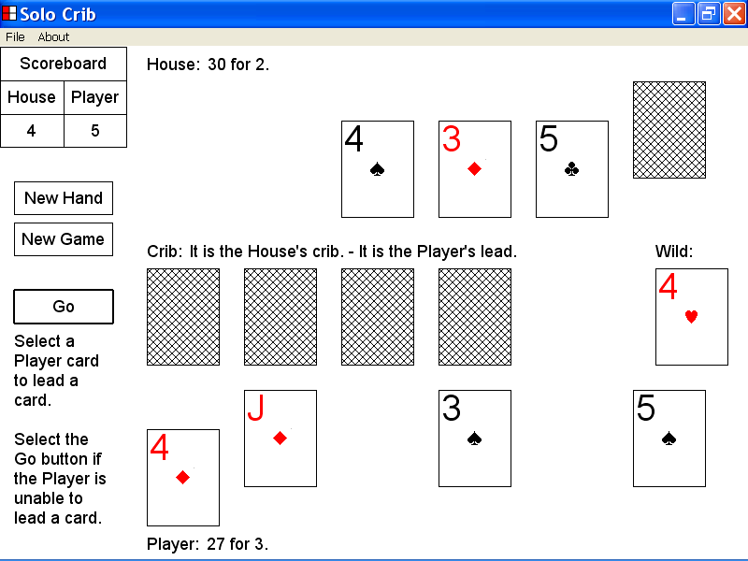

The Information message box

The House message box is identified with a label in the illustration of the Solo Crib program window below.

The House message box displays messages related to the pegging maneuvers of the House contestant.

The House message box also displays messages related to the points scored by the House contestant.

In the illustration below the current House message is “10.”, which is the new pegging sum in the current pegging series.

The House messages are posted by the Solo Crib program.
The House message box

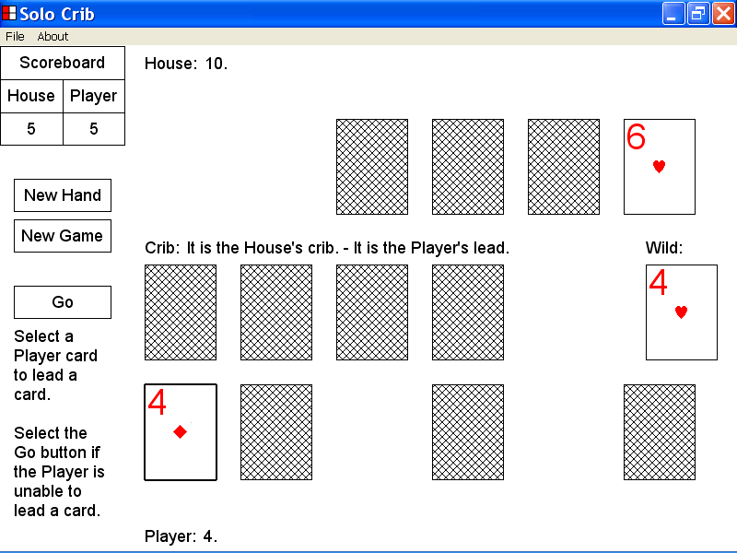

The Crib message box is identified with a label in the illustration of the Solo Crib program window below.

The Crib message box displays a message to identify the contestant that currently owns the crib.

The Crib message box also displays a message that identifies the contestant that is required to lead the next card.

In the illustration below the current Crib message is “It is the House’s crib. – It is the Player’s lead.” .

The Crib messages are posted by the Solo Crib program.
The Crib message box

The Player message box is identified with a label in the illustration of the Solo Crib program window below.

The Player message box displays messages related to the pegging maneuvers of the Player contestant.

The Player message box also displays messages related to the points scored by the Player contestant.

In the illustration below, the current Player message is “10 is a go.”

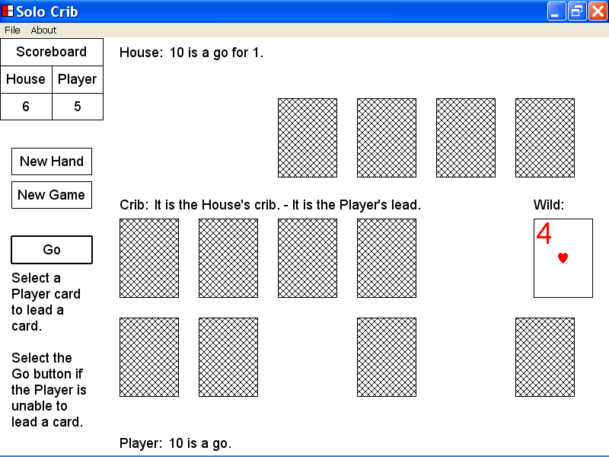
The Player message box

The House cards are identified with a label in the illustration of the Solo Crib program window below.

The House cards are led by the House contestant during a pegging series and enable the House to earn pegging points.

The House cards are evaluated at the end of a hand of cribbage when the hands are counted.

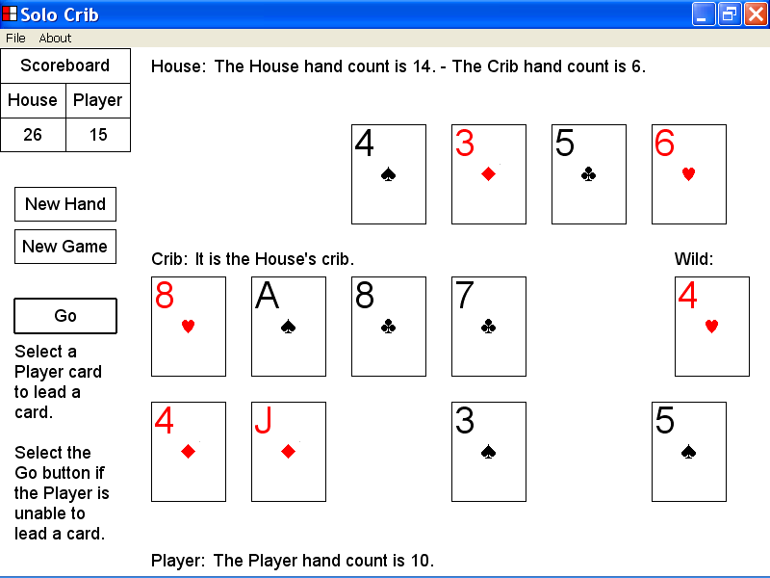
The House cards

The Player cards are identified with a label in the illustration of the Solo Crib program window below.

The Player cards are led by the Player contestant during a pegging series and enable the Player to earn pegging points.

The Player cards are evaluated at the end of a hand of cribbage when the hands are counted.

The Player cards

The Crib cards are identified with a label in the illustration of the Solo Crib program window below.

The Crib cards are evaluated at the end of a hand of cribbage when the hands are counted.

The Crib cards

The Wild card is identified with a label in the illustration of the Solo Crib program window below.

The Wild card is evaluated with the House cards, with the Player cards and with the Crib cards at the end of a hand of cribbage when the hands are counted.

The Wild card

6)How to set keyboard focus to a control by using the Tab key

This section of the documentation provides information about how to set keyboard focus to a control by using the Tab key.

In the Solo Crib program, the Tab sequence of controls is the New Hand button, the New Game button, the Go button, the first House card if visible, the second House card if visible, the third House card if visible, the fourth House card if visible, the fifth House card if visible, the sixth House card if visible, the first Crib card if visible, the second Crib card if visible, the third Crib card if visible, the fourth Crib card if visible, the Wild card, the first Player card if visible, the second Player card if visible, the third Player card if visible, the fourth Player card if visible, the fifth Player card if visible and the sixth Player card if visible.

If you press the Tab key keyboard focus is set to the next control in the Tab sequence.

If the last control in the Tab sequence has keyboard focus, you can press the Tab key to set keyboard focus to the first control in the Tab sequence.

In the illustration below, the New Hand button is the selected control and is highlighted with a double thickness rectangle.

In the Solo Crib program, the selected control has keyboard focus and keyboard input is directed to the functionality of the selected control.

If the New Hand button is the selected control, you can start a new hand of cribbage by pressing the Enter key.

If the New Hand button is the selected control, you can set keyboard focus to the New Game button by pressing the Tab key.

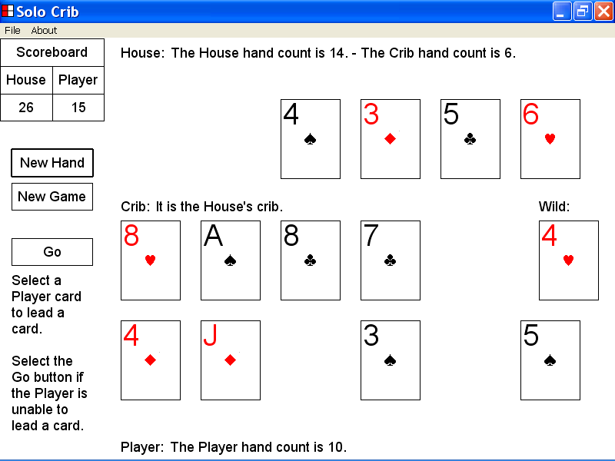
The New Hand button is the selected control and has keyboard focus.

In the illustration below, the New Hand button was the selected control.

Keyboard focus has been set to the New Game button by pressing the Tab key.

The New Game button is the new selected control and is highlighted with a double thickness selection rectangle.

Keyboard input will now be directed to the functionality of the New Game button.

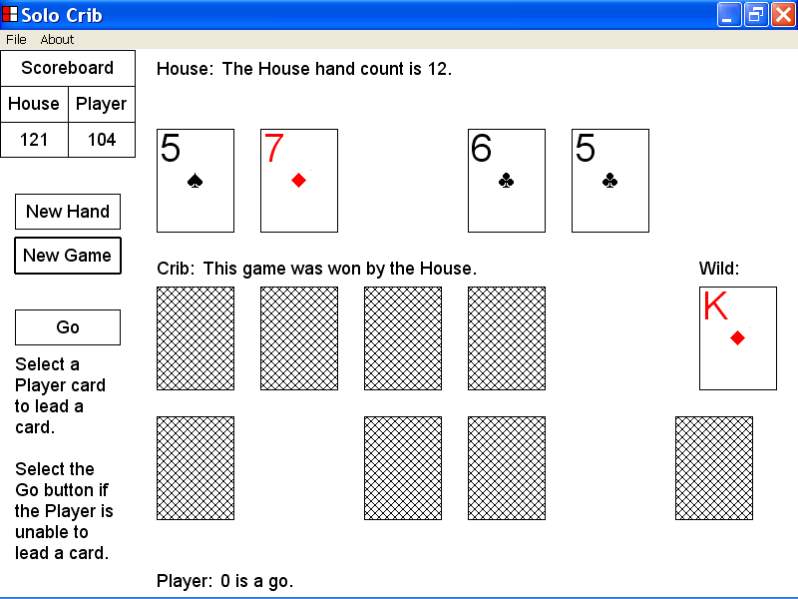
The old selected control
The New Game button is the new selected control.

7)How to set keyboard focus to a control by using the Arrow keys

This section of the documentation provides information about how to set keyboard focus to a control by using the Arrow keys.

You can use the Down Arrow key to set keyboard focus to a control that is below the currently selected control.

You can use the Up Arrow key to set keyboard focus to a control that is above the currently selected control.

You can use the Left Arrow key to set keyboard focus to a control that is to the left of the currently selected control.

You can use the Right Arrow key to set keyboard focus to a control that is to the right of the currently selected control.

In the illustration below, the first House card is the selected control and is highlighted with a double thickness selection rectangle.

If the first House card is the selected control keyboard input is directed to the functionality of the first House card.

If the first House card is the selected control, you can set focus to the first Crib card by pressing the Down Arrow key.

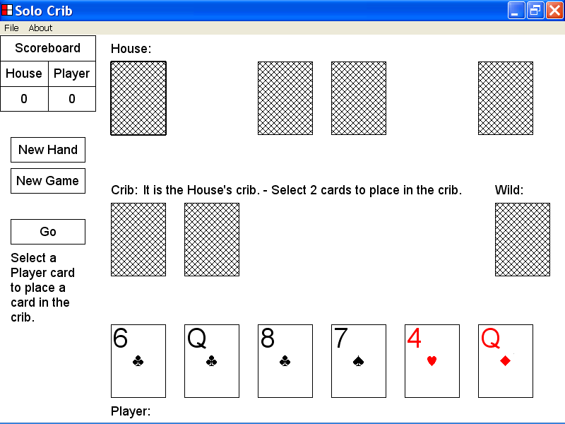
The first House card is the selected control.

The first Crib card

In the illustration below, the first House card was the selected control.

Keyboard focus has been set to the first Crib card by pressing the Down Arrow key.

The first Crib card is the new selected control and is highlighted with a double thickness selection rectangle.

Keyboard input will now be directed to the functionality of the first Crib card.

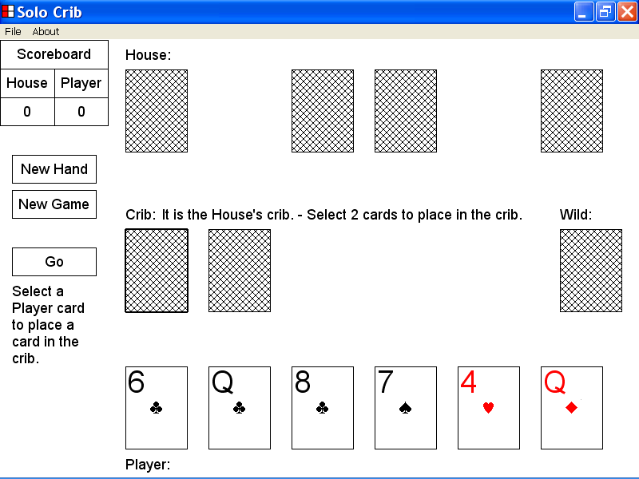
The old selected control
The first Crib card is the new selected control.

In the illustration below the first Crib card is the selected control and is highlighted with a double thickness selection rectangle.

If the first Crib card is the selected control, you can set keyboard focus to the last House card by pressing the Up Arrow key.

The first Crib card is the selected control.
The last House card

In the illustration below, the first Crib card was the selected control.

Keyboard focus has been set to the last House card by pressing the Up Arrow key.

The last House card is now the selected control and is highlighted with a double thickness selection rectangle.

Keyboard input will now be directed to the functionality of the last House card.

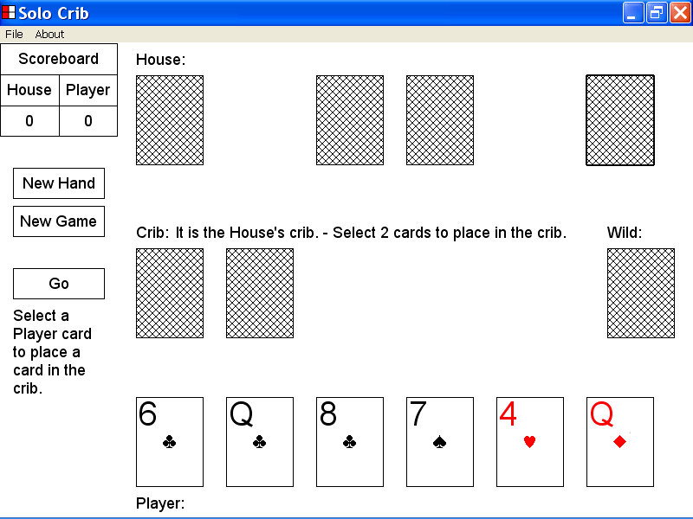
The last House card is the new selected control.
The old selected control

In the illustration below, the last House card is the selected control and is highlighted with a double thickness selection rectangle.

If the last House card is the selected control, you can set keyboard focus to the second last House card by pressing the Left Arrow key.
The second last House card
The last House card is the selected control

In the illustration below, the last House card was the selected control.

Keyboard focus has been set to the second last House card by pressing the Left Arrow key.

The second last House card is now the selected control and is highlighted with a double thickness selection rectangle.

Keyboard input will now be directed to the functionality of the second last House card.
The second last House card is the new selected control.
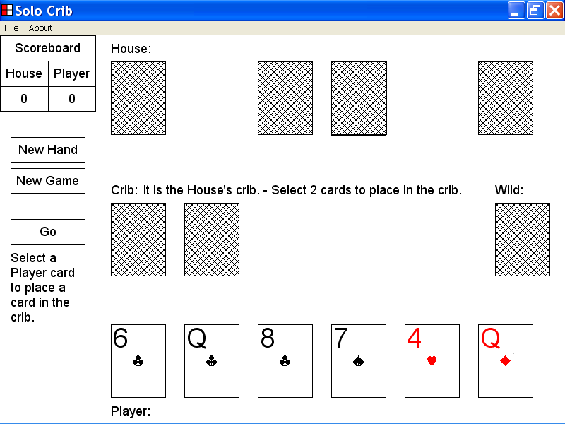
The old selected control

In the illustration below, the second last House card is the selected control and is highlighted with a double thickness selection rectangle.

If the second last House card is the selected control, you can set keyboard focus to the last House card by pressing the Right Arrow key.

The second last House card is the selected control.
The last House card

In the illustration below, the second last House card was the selected control.

Keyboard focus has been set to the last House card by pressing the Right Arrow key.

The last House card is now the selected control and is highlighted with a double thickness selection rectangle.

Keyboard input will now be directed to the functionality of the last House card.
The old selected control
The last House card is the new selected control.

8)How to place a Player card in the crib by using the keyboard keys

This section of the documentation provides information about how to place a Player card in the crib by using the keyboard keys.

In the illustration below, the Solo Crib program window is displayed and a new hand of cribbage has just started.

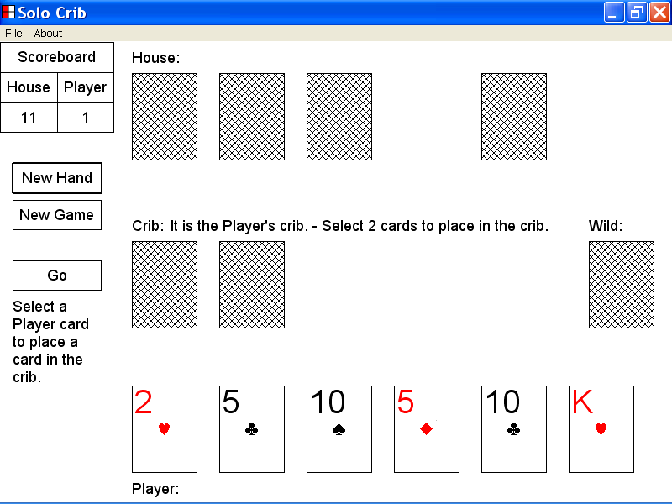

In the illustration below, the Solo Crib program has already placed two House cards in the crib.

In the illustration below, the Crib message is “It is the Player’s crib. - Select 2 cards to place in the crib.” .

The Player contestant is required to place two Player cards in the crib before the first pegging series can start.

If the first pegging series has not yet started, you can place a Player card in the crib by setting keyboard focus to the Player card and then pressing the Enter key.

The Crib message

In the illustration of the Solo Crib program window below, a new hand of cribbage has just started and the first pegging series has not yet started.

Keyboard focus has been set to the first Player card by using the Tab key.

If the first pegging series has not yet started, and if the selected control is a Player card, you can place the selected Player card in the crib by pressing the Enter key.

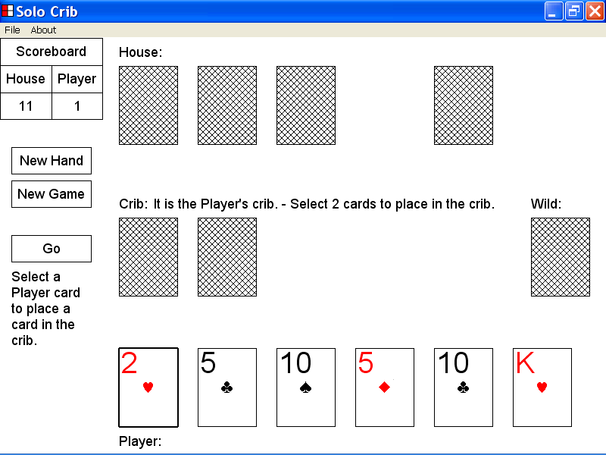
The first Player card is the selected control.

In the illustration of the Solo Crib program window below, the first Player card has been placed in the crib by setting keyboard focus to the first Player card and pressing the Enter key.

There are now 3 cards in the crib as illustrated below.

The new Crib message is “It is the Player’s crib. - Select 1 more card to place in the crib.” .

The Tab key was pressed 4 times to set keyboard focus to the last Player card. The last Player card is now the selected control and is highlighted with a double thickness selection rectangle.

If the first pegging series has not yet started, and if the selected control is a Player card, you can place the selected Player card in the crib by pressing the Enter key.

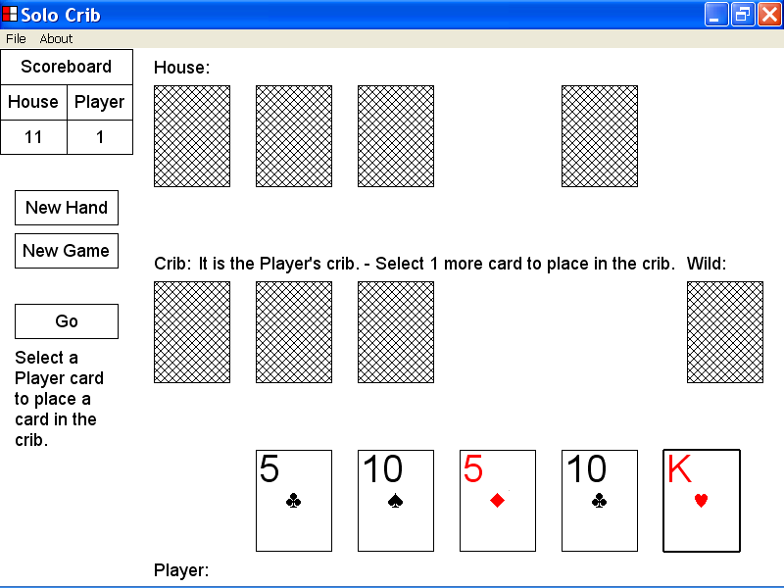

In the illustration below, the last Player card has been placed in the crib by setting keyboard focus to the last Player card and pressing the Enter key.

There are now 4 cards in the crib as illustrated below.

The new Crib message is “It is the Player’s crib – It is the Player’s lead.” .

The Wild card, the 7 of Diamonds, is now displayed with the face up.

The new Crib message and the display of the Wild card with the face up, indicate that the first pegging series has started.

The Solo Crib program has already led the first card of the pegging series, the 8 of Hearts.

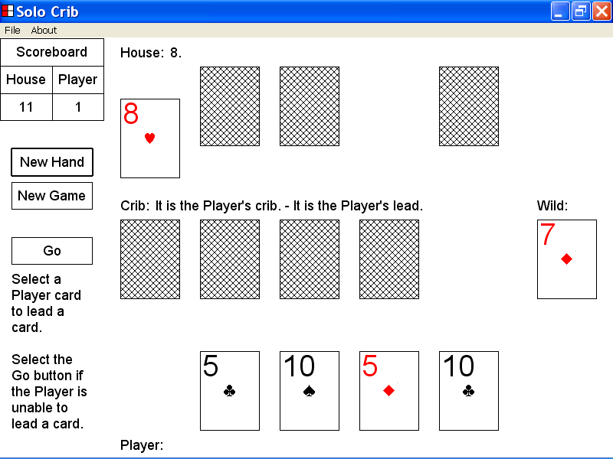

9)How to place a Player card in the crib by using the mouse device

This section of the documentation provides information about how to place a Player card in the crib by using the mouse device.

In the illustration below, the Solo Crib window is displayed and a new hand of cribbage has just started.

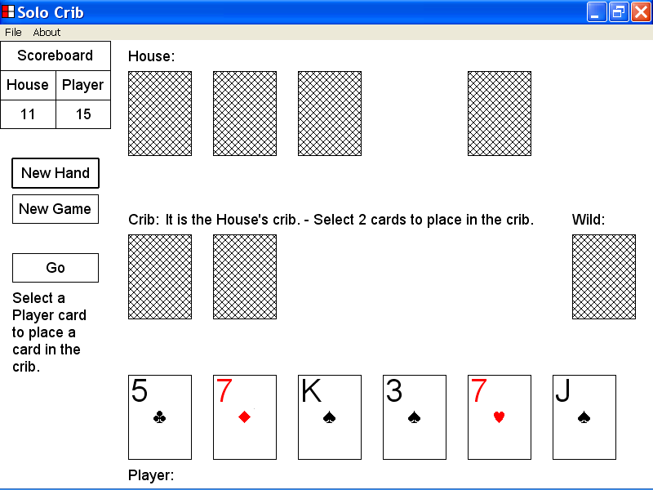

In the illustration below, the Solo Crib program has already placed two House cards in the crib.

In the illustration below, the Player message is “It is the House’s crib. - Select 2 cards to place in the crib.” .

The Player contestant is required to place two Player cards in the crib before the first pegging series can start.

If the first pegging series has not yet started, you can place a Player card in the crib, by left clicking the Player card with the mouse device.

In the illustration of the Solo Crib program window below, the third Player card has been placed in the crib by left clicking the third Player card with the mouse device.

There are now 3 cards in the crib as illustrated below.

The new Crib message is “It is the House’s crib. - Select 1 more card to place in the crib.” .

If the first pegging series has not yet started, you can place a Player card in the crib by left clicking the Player card with the mouse device.

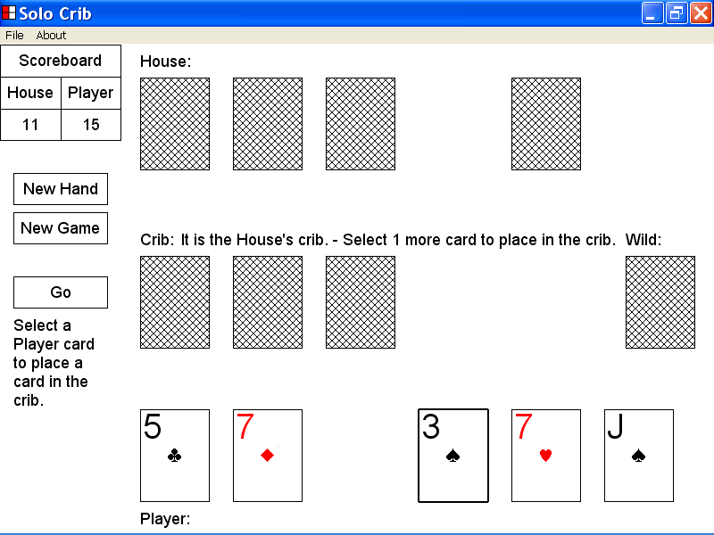

In the illustration below, the last Player card has been placed in the crib by left clicking the last Player card with the mouse device.

There are now 4 cards in the crib as illustrated below.

The new Crib message is “It is the House’s crib. – It is the Player’s lead.” .

The Wild card, the 8 of Diamonds, is now displayed with the face up.

The new Crib message and the display of the Wild card with the face up, indicate that the first pegging series has started.

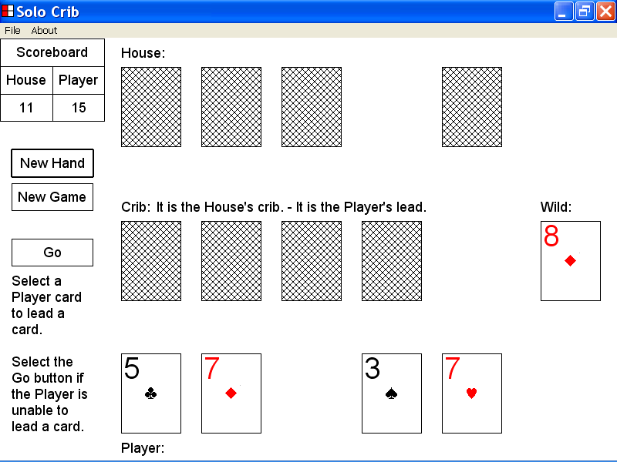

10)How to lead a Player card by using the keyboard keys

This section of the documentation provides information about how to lead a Player card by using the keyboard keys.

In the illustration below, the Solo Crib program window is displayed and a new hand of cribbage has just started.

Two House cards and two Player cards have already been placed in the crib.

The Crib message is “It is the House’s crib. – It is the Player’s lead.” .

If it is the Player’s lead in the current pegging series, you can lead a Player card by setting keyboard focus to the Player card and then pressing the Enter key.

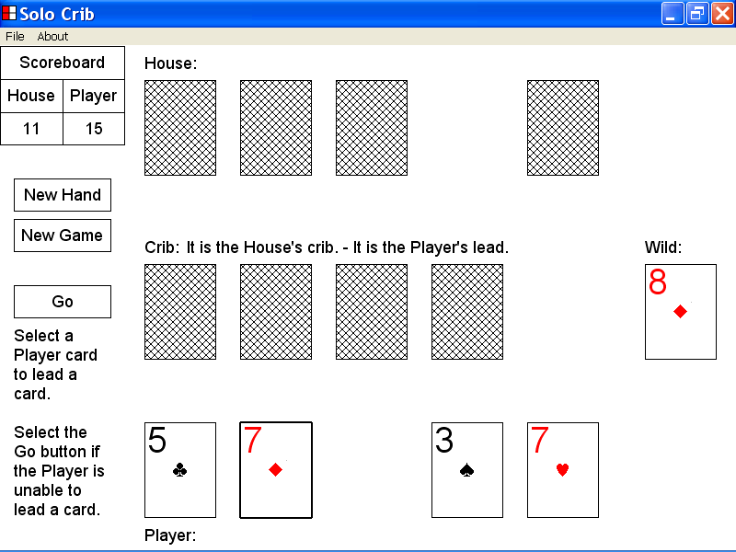

In the illustration below, keyboard focus has been set to the second Player card, the 7 of Diamonds, by using the Tab key.

The second Player card is now the selected card and is highlighted with a double thickness selection rectangle.

If it is the Player’s lead in the current pegging series, and if a Player card is the selected object, you can lead the selected Player card by pressing the Enter key.

In the illustration below the second Player card has been led in the current pegging series by setting keyboard focus to the card and pressing the Enter key.

The Player message is now “7”, which indicates the pegging sum after the most recent Player card was led.

After the second Player card, the 7 of Diamonds was led, the Solo Crib program led the first House card, the 4 of Diamonds as illustrated below.

The new House message is “11”. This message indicates that the current pegging sum is now 11.

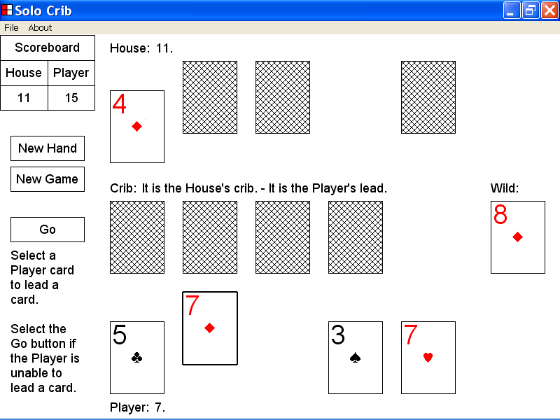

11)How to lead a Player card by using the mouse device

This section of the documentation provides information about how to lead a Player card by using the mouse device.

In the illustration below, the Solo Crib program window is displayed and a new hand of cribbage has just started.

Two House cards and two Player cards have already been placed in the crib.

The Solo Crib program has just led the first House card, the 9 of Diamonds, as the first lead of the pegging series.

The new House message is “9”, which indicates that the current pegging sum is 9.

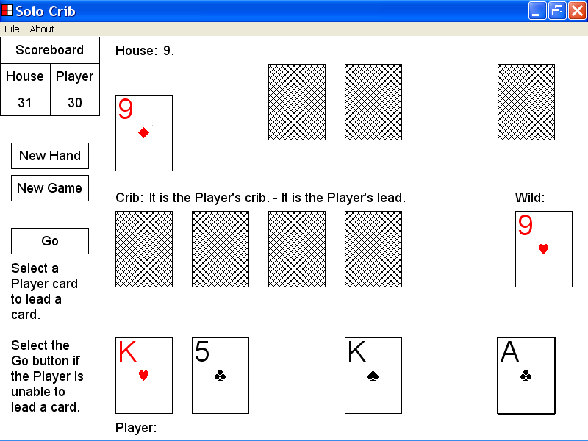

In the illustration below, a new hand of cribbage has just started and the Solo Crib program has just led the first House card, the 9 of Diamonds, as the first lead of the current pegging series.

The new Crib message is “It is the Player’s crib. – It is the Player’s lead.”, which indicates that it is the Player’s turn to lead a card.

If it is the Player’s lead in the current pegging series, you can lead a Player card by left clicking the Player card with the mouse device.

In the illustration below, the first Player card, the King of Hearts, has been led by left clicking the card with the mouse device.

The current Player message is now “19”, which indicates that the pegging sum after the most recent Player lead, was 19.

After the first Player card, the King of Hearts, was led, the Solo Crib program led the third House card, the 8 of Spades, as illustrated below.

The new House message is “27”, which indicates that the current pegging sum is now 27.

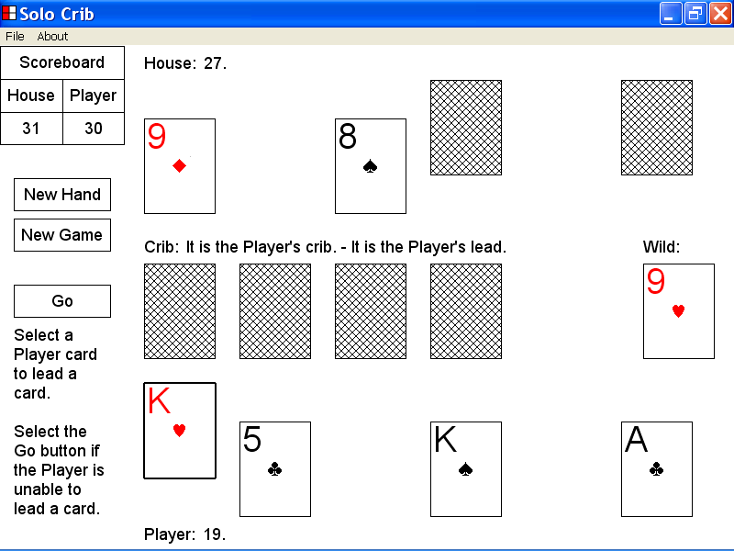

12)How to select the Go button to indicate that the Player contestant is unable to lead a card in the current pegging series

This section of the documentation provides information about how to select the Go button to indicate that the Player contestant is unable to lead a card in the current pegging series.

In the illustration below the House message is “28 is a go.” . This message indicates that the current pegging sum is 28 and that the House contestant is unable to lead a card.

The current Crib message is “It is the Player’s crib. – It is the Player’s lead.” . This message indicates that it is the Player’s turn to lead a card in the current pegging series.

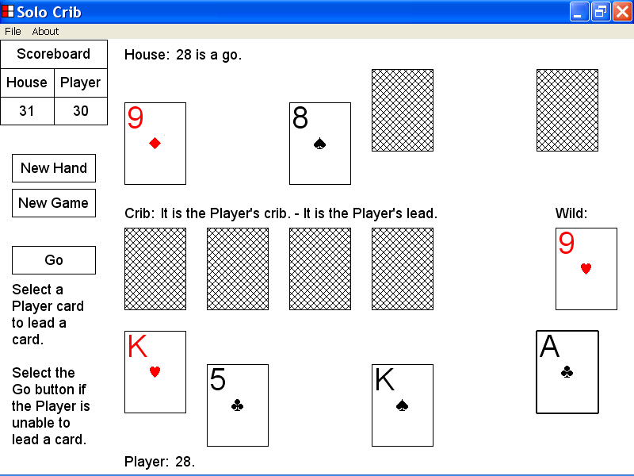

In the illustration below, an attempt was made to lead the second Player card, the 5 of Clubs, by left clicking the card with the mouse device.

The Can Not Play Card message box was displayed as the value of the Player card, the 5 of Clubs, would create a pegging sum that was greater than 31, which is the pegging sum limit.

You can close the Can Not Play Card message box by left clicking the OK button of the message box with the mouse device.

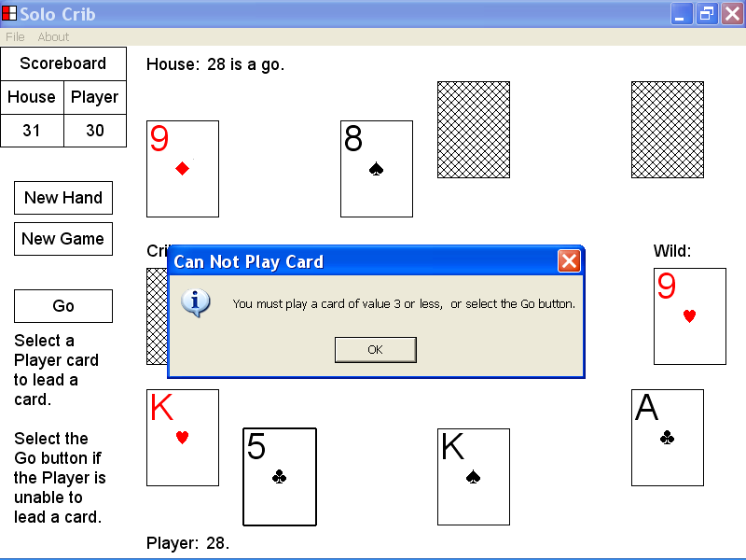

In the illustration below, the Can Not Play Card message box has been closed, by selecting the OK button of the message box with the mouse device.

It is now possible to select the Go button to indicate that the Player is unable to lead a card in the current pegging series.

If it is the Player’s lead, you can select the Go button by left clicking the Go button with the mouse device.

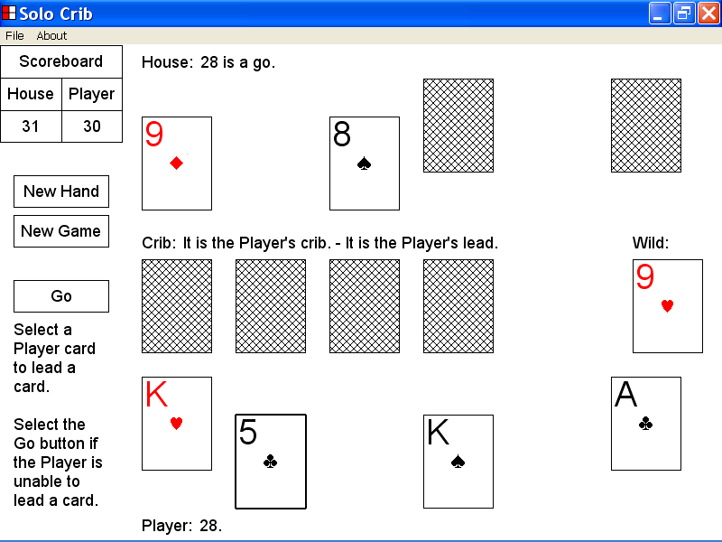

In the illustration below, the Go button was selected to indicate that the Player contestant was unable to lead a card in the current pegging series.

The new Player message is “28 is a go for 1.”, This message indicates that the current pegging sum was 28, that the Player was unable to lead a card and that the Player earned 1 pegging point.

After the Go button was selected to indicate that the Player was unable to lead a card, the Solo Crib program turned the cards of the current pegging series face down to start a new pegging series. The Solo Crib program then led the third House card, the 7 of Diamonds, as the first lead of the new pegging series.

The new House message is “7.” . This message indicates that the new pegging sum is 7.

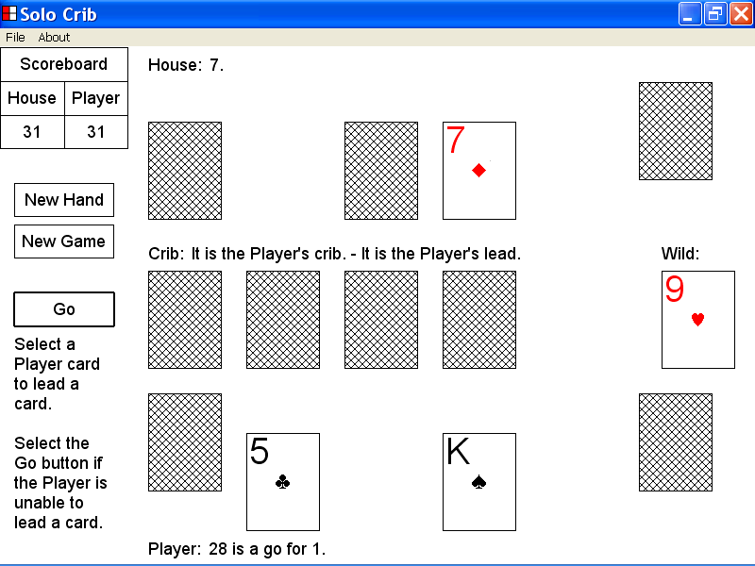

13)The counting of hands at the end of a hand of cribbage

This section of the documentation provides information about the counting of hands, at the end of a hand of cribbage.

The counting of hands at the end of a hand of cribbage takes place when the following conditions exist.

The House has played 4 cards in the current hand of cribbage.

The Player has played 4 cards in the current hand of cribbage.

A pegging series has just ended in which no House cards and no Player cards were played.

When the conditions above apply, the Solo Crib program counts the cribbage hands, posts House messages and Player messages that describe the points earned, and makes adjustments to the House score and to the Player score.

In the illustration below, the House contestant has already played 4 cards and the Player contestant has already played 4 cards in the current hand of cribbage.

In the current pegging series, the House contestant was unable to lead a card.

The House message is “0 is a Go.” .

The Crib message is “It is the Player’s crib. – It is the Player’s lead.”, which indicates that it is the Player’s turn to lead a card.

In the illustration below, you can direct the Solo Crib program to count the hands at the end of the current hand of cribbage by selecting the Go button.

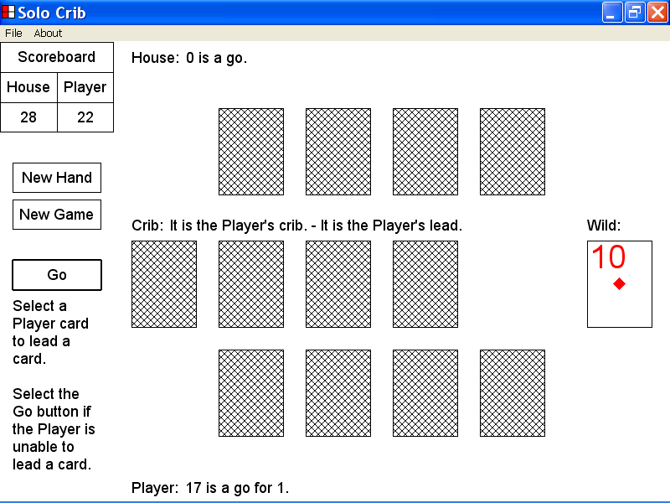

In the illustration above, all House cards and all Player cards had already been played. In the last pegging series of the hand of cribbage, no cards had been led by the House and no cards had been led by the Player.

The Crib message indicated that it was the Player’s turn to lead a card.

In the illustration below, the Player ended the last pegging series of the current hand, by selecting the Go button as described above.

After the Go button was selected, the Solo Crib program counted the cribbage hands at the end of the current hand of cribbage as illustrated below.

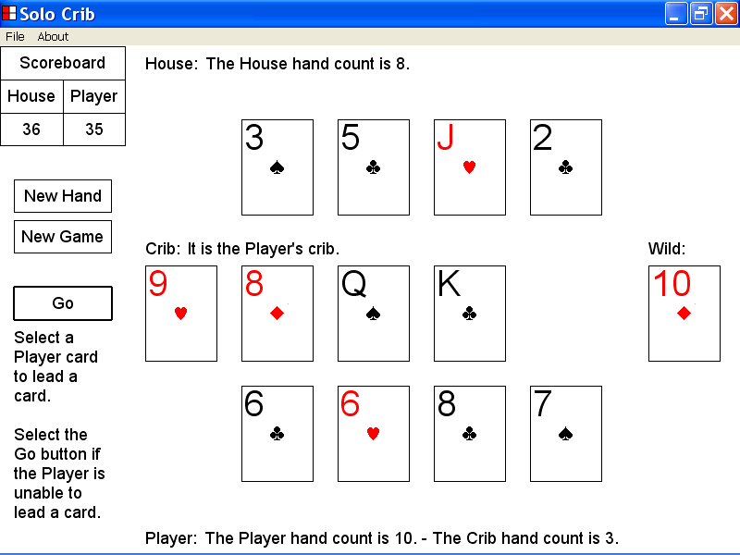

In the illustration above the Player directed the Solo Crib program to count the cribbage hands at the end of the current hand of cribbage, by selecting the Go button.

The new Player message is “The Player hand count is 10. – The Crib hand count is 3.” . This message indicates that the Player hand was counted as containing 10 points by the Solo Crib program. This message also indicates that the Crib hand was counted as containing 3 points by the Solo Crib program.

As the Crib message indicates, the Player contestant was considered the owner of the crib for this hand of cribbage, and the points awarded to the Crib hand were posted to the score of the Player contestant.

As illustrated by the Scoreboard, 10 points were posted to the Player score based on the value of the Player hand, and 3 points were posted to the Player score based on the value of the Crib hand.

As illustrated by the Scoreboard, 13 points in all were posted to the Player score, which increased the Player score from 22 to 35.

The new House message is “The House hand count is 8.” . This message indicates that the House hand was counted as containing 8 points by the Solo Crib program.

As illustrated by the Scoreboard, 8 points were posted to the House score, which increased the House score from 28 to 36.

When the Solo Crib program has finished counting the hands at the end of the current hand of cribbage, as illustrated below, you can select the New Hand button to start a new hand of cribbage.

You can select the New Hand button to start a new hand of cribbage by left clicking the New Hand button with the mouse device.

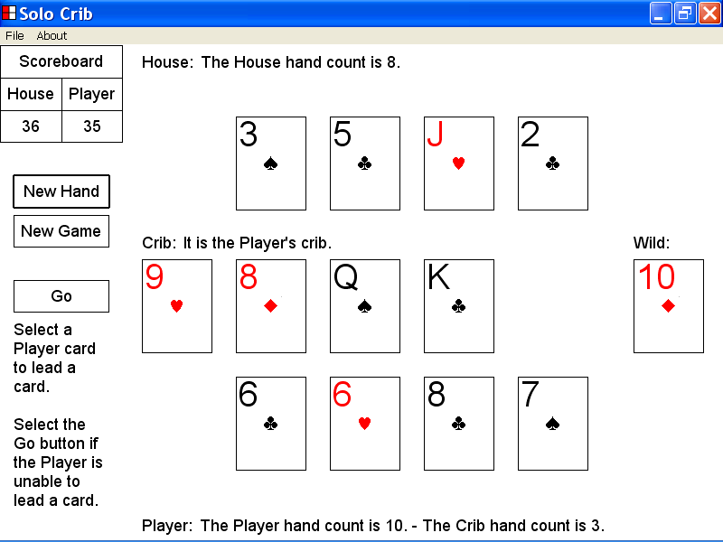
The New Hand button

14)How to select the New Hand button to start a new hand of cribbage

This section of the documentation provides information about how to select the New Hand button to start a new hand of cribbage.

In the illustration below, the Solo Crib program has just completed the counting of hands at the end of a hand of cribbage.

You can select the New Hand button by setting keyboard focus to the button and then pressing the Enter key.

You can also select the New Hand button by setting keyboard focus to the button and then pressing the Spacebar key.

You can also select the New Hand button to start a new hand of cribbage by left clicking the New Hand button with the mouse device.

In the illustration below, the New Hand button was selected by left clicking the button with the mouse device.

The Solo Crib program has dealt six new House cards, six new Player cards and a new Wild card.

The Solo Crib program has placed two House cards in the crib.

The current House score and the current Player score are not affected by selecting the New Hand button.

The new Crib message is “It is the House’s crib. – Select 2 cards to place in the crib.” . This message indicates that the Player contestant is required to place two Player cards in the crib before the first pegging series can start.

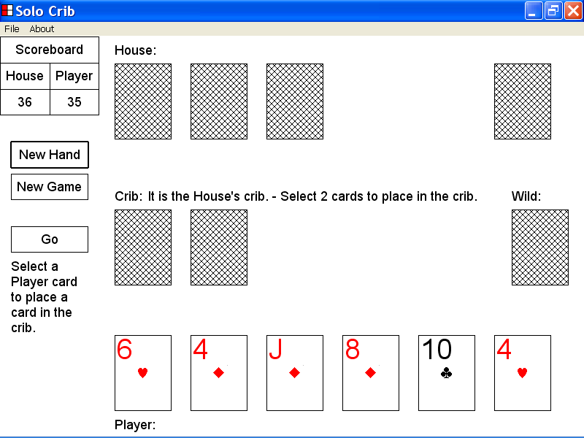

If you select the New Hand button as described above, the ownership of the crib alternates between the House contestant and the Player contestant.

In the illustration below the old owner of the crib was the Player contestant.

After selecting the New Hand button, the new owner of the crib is the House contestant.

The new Crib message is “It is the House’s crib. – Select 2 cards to place in the crib.” .

15)How to select the New Game button to start a new game of cribbage

This section of the documentation provides information about how to select the New Game button to start a new game of cribbage.

In the illustration below, the current game of cribbage was won by the House contestant.

You can select the New Game button to start a new game of cribbage by left clicking the New Game button with the mouse device.

You can also select the New Game button by setting keyboard focus to the New Game button and then pressing the Enter key.

You can also select the New Game button by setting keyboard focus to the button and then pressing the Spacebar key.

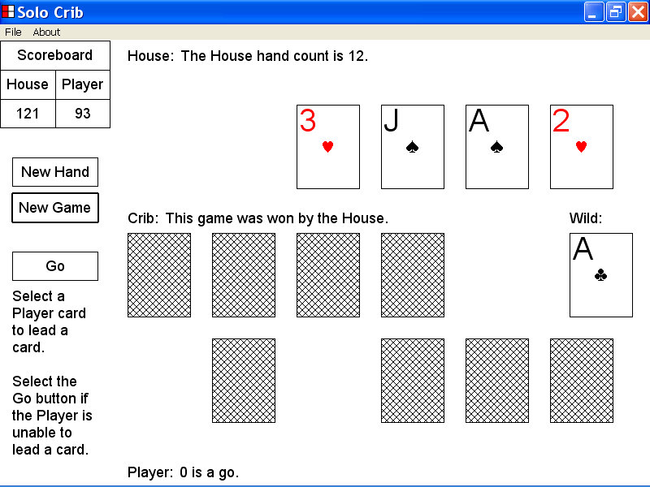
In the illustration below, the New Game button was selected by left clicking the button with the mouse device.

The Solo Crib program has dealt six new House cards, six new Player cards and a new Wild card.

The Solo Crib program has placed two House cards in the crib.

The House score has been reset to 0 and the Player score has been reset to 0.

The new Crib message is “It is the House’s crib. - Select 2 cards to place in the crib.” . This message indicates that the Player contestant is required to place two Player cards in the crib before the first pegging series can start.

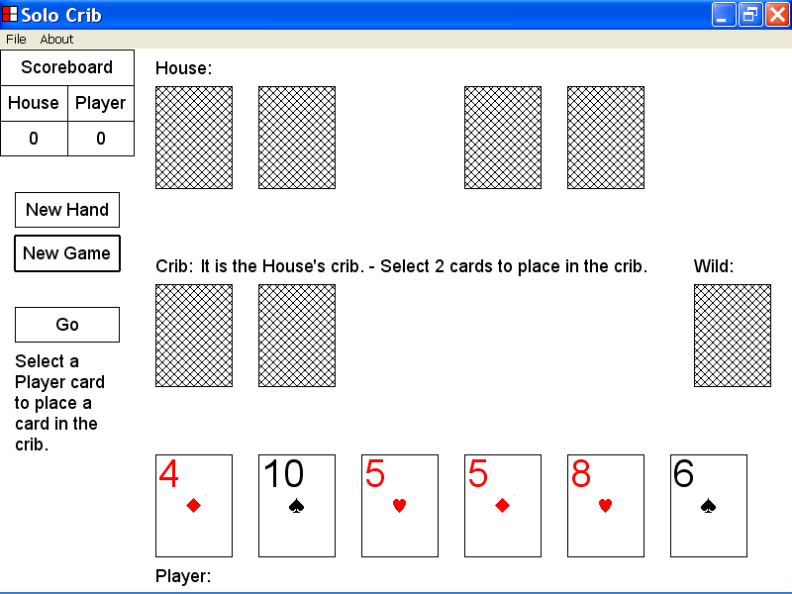

If you select the New Game button as described above, the ownership of the crib alternates between the House contestant and the Player contestant.

In the illustration below, the old owner of the crib was the Player contestant.

After the selection of the New game button, the new owner of the crib is the House contestant.

The new Crib message is “It is the House’s crib. – Select 2 cards to place in the crib.” .

16)How to set the set the display configuration of a card

This section of the documentation provides information about how to set the display configuration of a card.

In the illustration below, a hand of cribbage has just started.

The House cards, the Crib cards, and the Wild card are displayed with the face down by the Solo Crib program at the start of a new hand of cribbage.

You can set the display configuration of a House card, a Crib card or the Wild card by selecting the card with the mouse device.

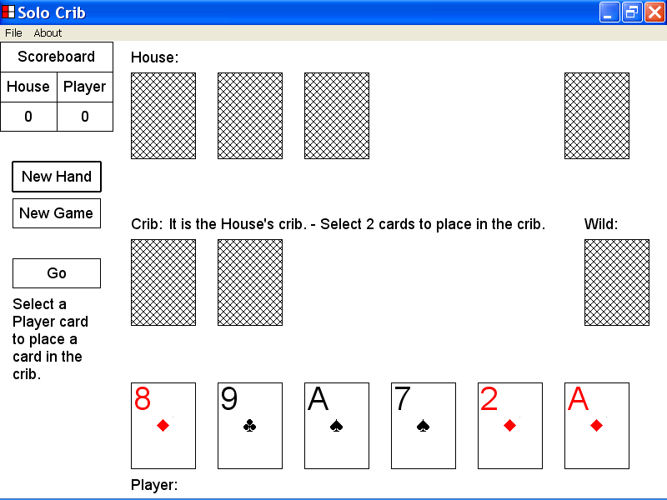

In the illustration below, the first House card was displayed with the face down at the start of a new hand of cribbage.

In the illustration below, the display configuration of the first House card was reversed by selecting the card with the mouse device.

The first House card, the Jack of Spades, is now displayed with the face up.

You can also set the display configuration of a House card, a Crib card or the Wild card by setting keyboard focus to the card and pressing the Enter key.

You can also set the display configuration of a House card, a Crib card or the Wild card by setting keyboard focus to the card and pressing the Spacebar key.

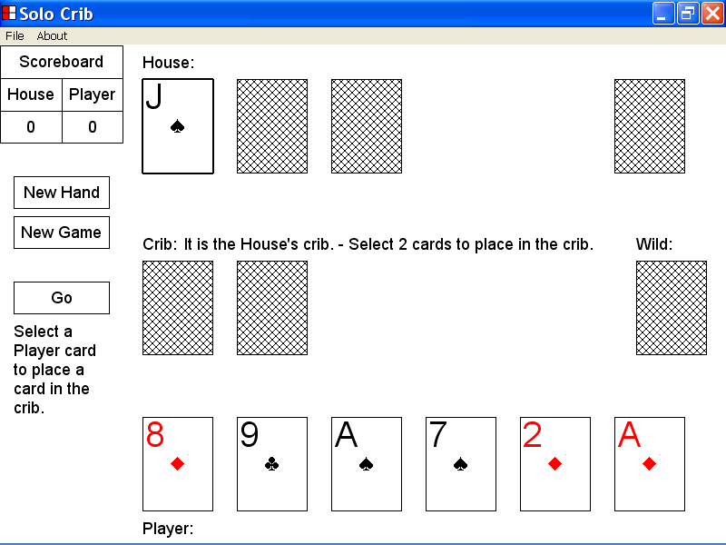

In the illustration below, a new pegging series has just started and the Solo Crib program has led the second House card, the Jack of Clubs.

The House cards and the Player cards that were led in the last pegging series are displayed with the face down by the Solo Crib program at the start of a new pegging series.

You can set the display configuration of a House card or a Player card that has already been led, by selecting the card with the mouse device.

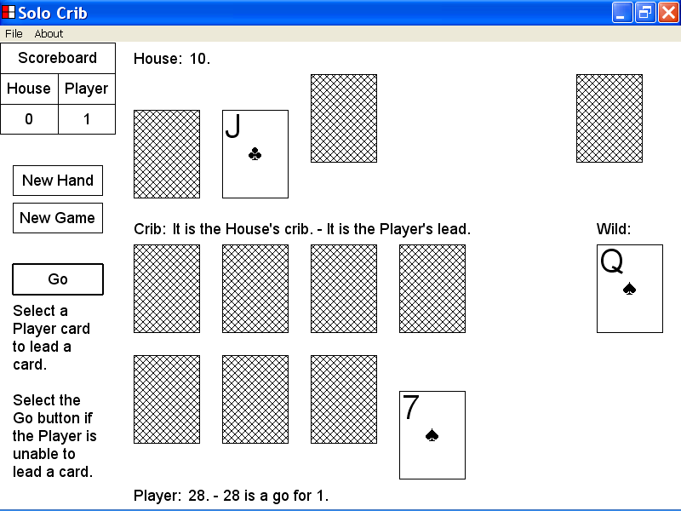

In the illustration below, the first Player card was displayed with the face down at the start of a new pegging series.

In the illustration below the display configuration of the first Player card was reversed by selecting the card with the mouse device.

The first Player card, the 8 of Diamonds, is now displayed with the face up.

You can also set the display configuration of a Player card that has already been led, by setting keyboard focus to the card and then pressing the Enter key.

You can also set the display configuration of a Player card that has already been led, by setting keyboard focus to the card and then pressing the Spacebar key.

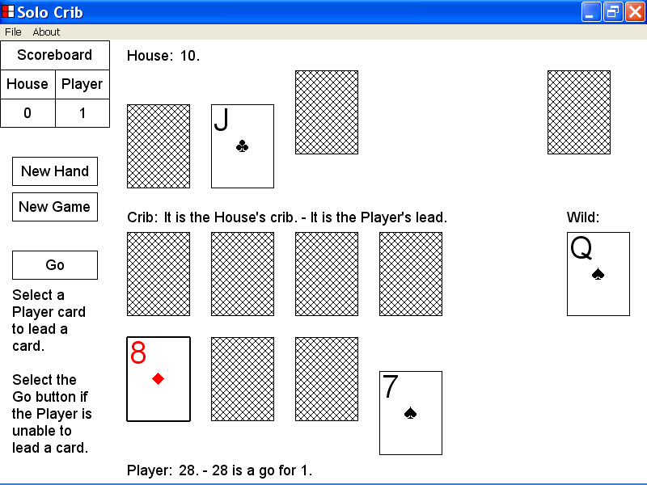

17)How to set the Stop Action Interval by using the File menu

This section of the documentation provides information about how to set the Stop Action Interval by using the File menu.

In some situations a series of House contestant maneuvers are performed by the Solo Crib program, before the Player contestant is required to lead a card.

A break is placed after each House cribbage maneuver equal to the time in seconds of the Stop Action Interval.

The Stop Action break allows you to see the cribbage maneuvers of the House contestant in greater detail.

The default setting of the Stop Action Interval is 1 second but you can set the Stop Action Interval by using the File menu as described below.

To set the Stop Action Interval by using the File menu, first left click the File menu with the mouse device and then select the Stop Action Interval pop up menu as illustrated below.

When you select the Stop Action Interval pop up menu the Stop Action Interval menu items are displayed as illustrated below.

In the illustration below the current setting of the Stop Action Interval is 1 second and is highlighted with a check mark beside the 1 second menu item.

You can set the Stop Action Interval to one of the menu item values by selecting the menu item with the mouse device.

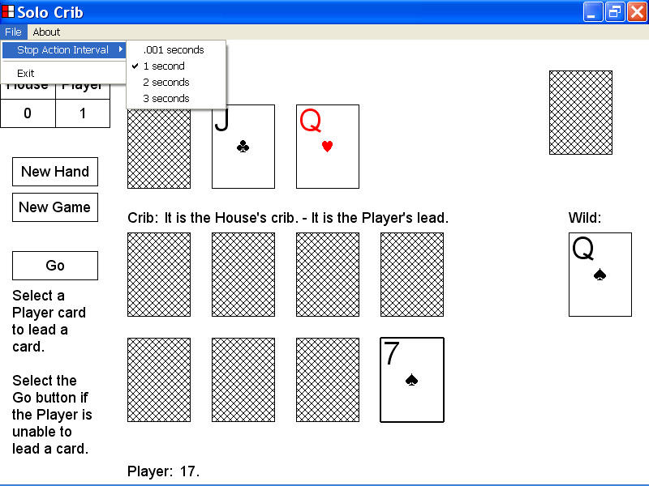

18)How to display copyright information about the Solo Crib computer program

This section of the documentation provides information about how to display copyright information about the Solo Crib computer program.

In the illustration below, the Solo Crib program window is displayed.

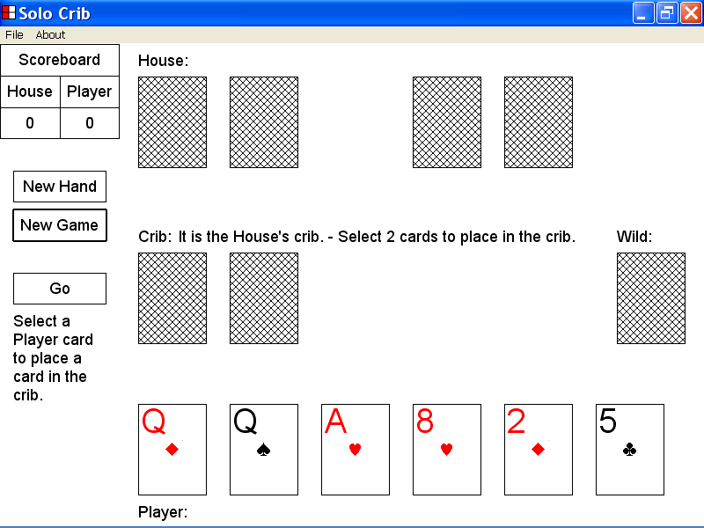

To display copyright information about the Solo Crib computer program left click the About menu on the menu bar as illustrated below, and then select the About Solo Crib ... menu item.

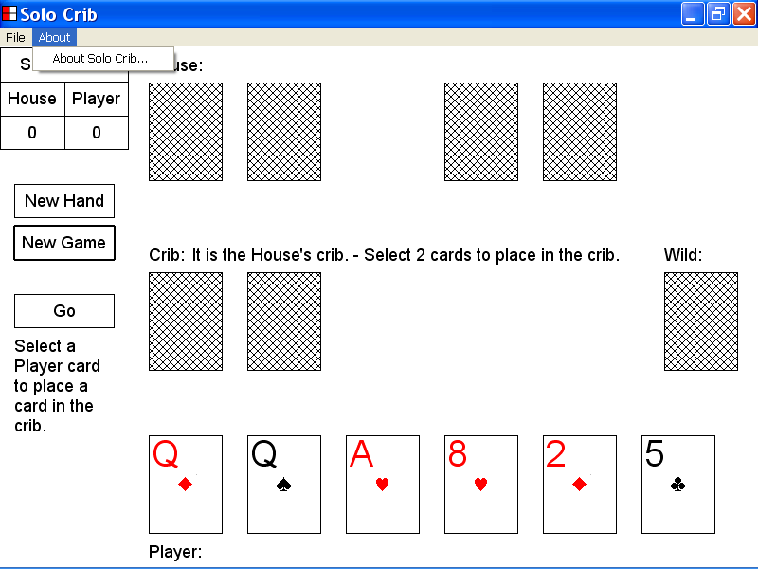

In the illustration below, the Solo Crib message box has been displayed by selecting the About Solo Crib . . . menu item of the About menu as described above.

The Solo Crib message box contains copyright information about the Solo Crib computer program.

You can close the Solo Crib message box by selecting the OK button of the Solo Crib message box with the mouse device.

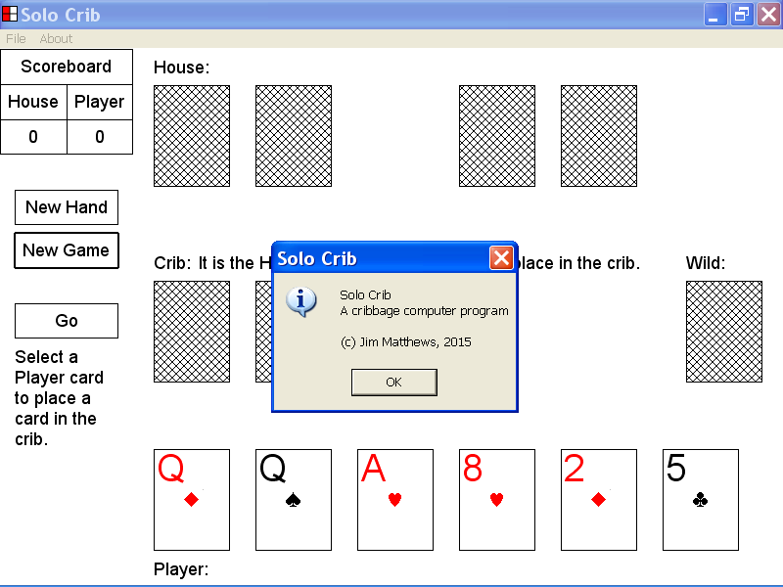

19)How to close the Solo Crib program by using the File menu

This section of the documentation provides information about how to close the Solo Crib program by using the File menu.

In the illustration below, the program window of the Solo Crib program is displayed.

You can close the Solo Crib program by left clicking the File menu on the menu bar, as illustrated below, and then selecting the Exit menu item.

