Table of Contents

Topic Page

1) General Information . . . . . . . . . . . 2
2) System Requirements . . . . . . . . . . . 3
3) How to obtain the Letter Maker For American program file from the Internet . . . 4
4) The components of the Letter Maker For American program. . . . . . . . . . . . . . . 20
5) The components of the Text Box control . . 22
6) How to set keyboard focus to the Text Box control . . . . . . . . . . . . . . . . . . . 31
7) How to insert a character into a document, by directing keyboard input to the Text Box control . . . . . . . . . . . . . . . . . . . 34
8) How to set the position of the caret in the Text Box control. . . . . . . . . . . . . 39
9) How to insert a new line into a text document, by pressing the Enter key . . . . . 85
10) How to insert four consecutive spaces into a text document, by pressing the Tab key . . . . . . . . . . . . . . . . . . . . . 88
11) How to delete a character of a text document, by pressing the Delete key. . . . . 91
12) How to delete a character of a text document, by pressing the Backspace key . . . 94
13) The components of the Letter Box control. 97
14) How to set keyboard focus to the Letter Box control . . . . . . . . . . . . . . . . . 105
15) How to insert a character into a text document, by directing keyboard input to the Letter Box control. . . . . . . . . . . . . . 119
16) How to insert a character into a text document, by directing mouse device input to the Letter Box control. . . . . . . . . . . . 124

1) General Information

This section of the documentation provides general information about the Letter Maker For American computer program.

Letter Maker For American is a computer program that allows you to create, edit, print and save text documents.

Letter Maker For American allows you to create text documents, that contain up to 32768 characters.

Letter Maker For American allows you to exchange sections of text with other Windows programs, using standard copy and paste techniques.

Many languages use letters, that are not found on a standard North American keyboard. Letter Maker For American allows you to easily include these letters in your text document.

2) System Requirements

This section of the documentation provides information about the system requirements of the Letter Maker For American program.

Letter Maker For American is designed to run on a computer, that provides the following requirements.

A Windows operating system is required. Letter Maker For American is designed to run on a standard North American version of Windows, that was produced in the 21st century. The documentation may differ slightly from the way your computer system works, if your computer is equipped with a non-North-American version of Windows, or if your computer is equipped with an older version of Windows.

A keyboard is required. Letter Maker For American is designed to use a standard North American keyboard. The documentation may differ slightly from the way your computer system works, if your computer is equipped with a non-North-American keyboard.

A monitor is required.

A mouse device is required.

Access to a local or network printer is required, to print the files, you create and edit.

Access to local or network storage media is required to save the files you create and edit.

3) How to obtain the Letter Maker For American program file from the Internet

This section of the documentation provides information about how to obtain the Letter Maker For American program file from the Internet.

You can obtain a copy of the Letter Maker For American program file, LetterMakerForAmerican.exe, from the Matthews Software Incorporated web site, www.matthewssoftware.ca .

In the illustration, below, the Microsoft Windows program, Internet Explorer, has been used to navigate to the Matthews Software Incorporated web site.

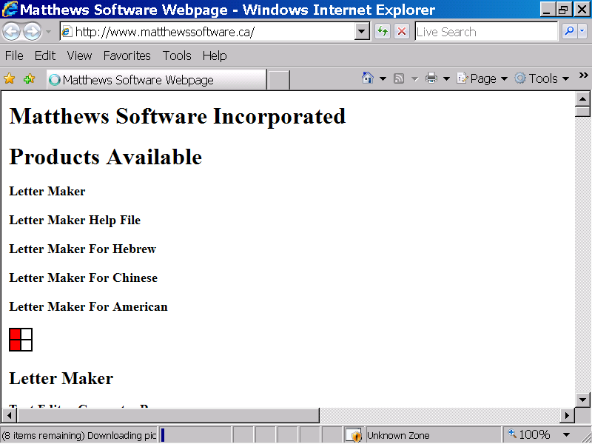
Scrollbar
You can use the scrollbar control to scroll to the section of the web page, where the Letter Maker For American program file, can be obtained.

In the illustration below, the section of the Matthews Software Incorporated web site, where the Letter Maker For American program file can be obtained, is displayed.

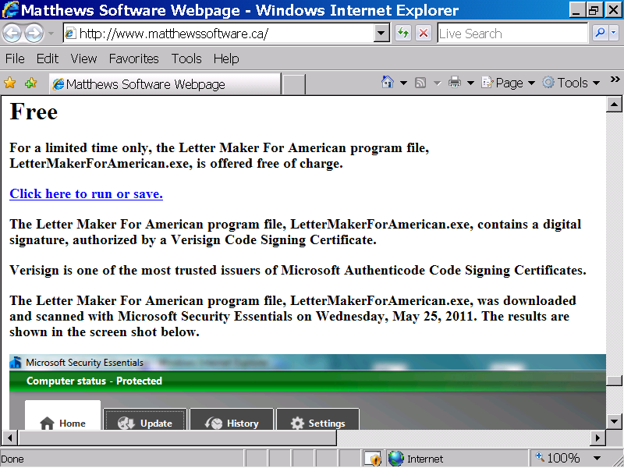
You can select the hyperlink with the caption, “Click here to run or save”, to save the Letter Maker For American program file to your computer system.

In the illustration below, the hyperlink with the caption, “Click here to run or save”, has been selected. As illustrated below, the File Download – Security Warning, message box, is now displayed.

Click the Save button to save the Letter Maker For American program file, LetterMakerForAmerican.exe to your computer.

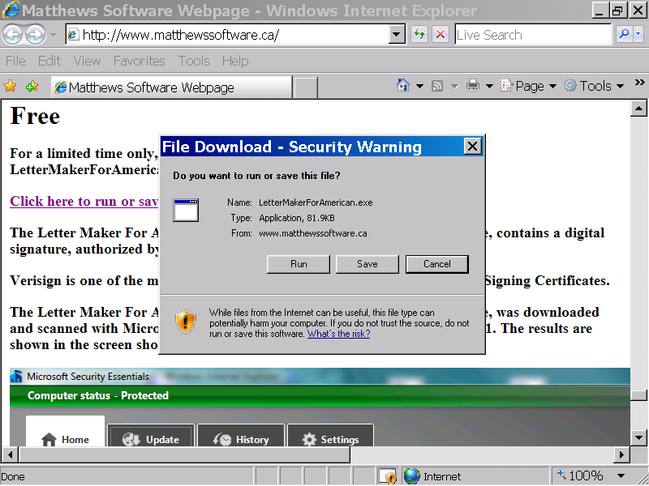

In the illustration below, the Save button of the Security Warning message box has been selected. As illustrated below, the Save As dialog box is now displayed.

The Save As dialog box allows you to specify a directory, where you would like the program file, LetterMakerForAmerican.exe to be stored.

In the illustration below, the Download directory has been selected, from the Save In list box.

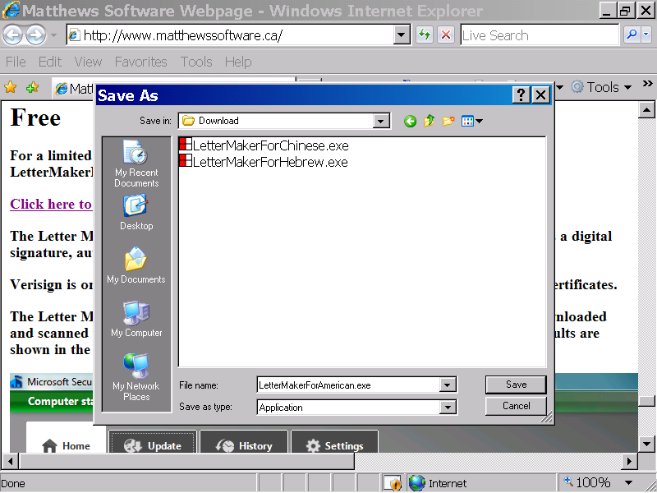
When you have selected a directory, you can left click the Save button, with the mouse device, to save the Letter Maker For American program file, LetterMakerForAmerican.exe, to your computer system.

In the illustration below, the Save button of the Save As dialog box has been selected. In the illustration below, the Letter Maker For American file, LetterMakerForAmerican.exe, has been successfully saved to the client computer system.

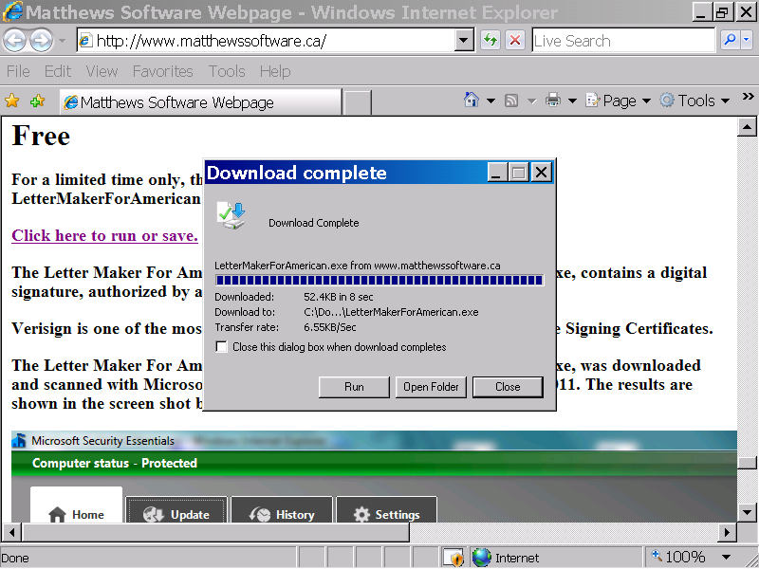

You can left click the Open Folder button, of the Download Complete dialog box, to display the folder, where the client copy of the Letter Maker For American program file has been saved.

In the illustration below, the Open Folder button of the Download Complete message box has been selected. As illustrated below, the client copy of the Letter Maker For American program file, is displayed.

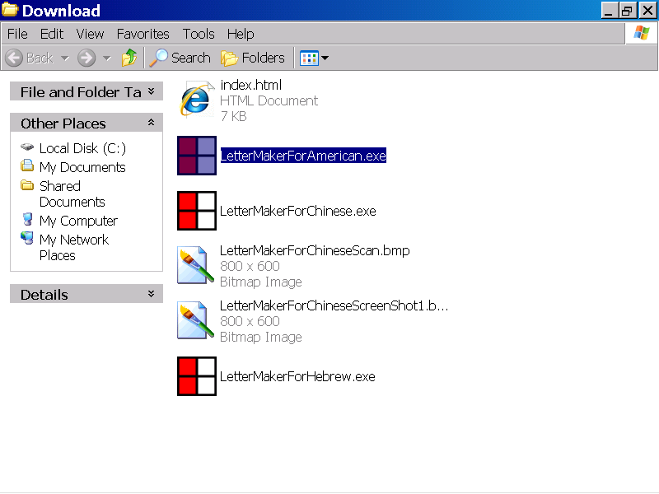

You can left click the icon with the caption, “LetterMakerForAmerican.exe”, to select the Letter Maker For American file.

When you have selected the program file, LetterMakerForAmerican.exe, as illustrated above, you can press the Enter button on your keyboard to start up the Letter Maker For American program.

In the illustration below, the Letter Maker For American program file has been selected, and the Enter button has been pressed. As illustrated below, the Open File – Security Warning dialog box is now displayed.

The Letter Maker For American program file, LetterMakerForAmerican.exe contains a Microsoft Authenticode digital Code Signing Certificate.

The digital certificate has been issued by VeriSign, one of the most trusted issuers of Microsoft Authenticode Code Signing Certificates.

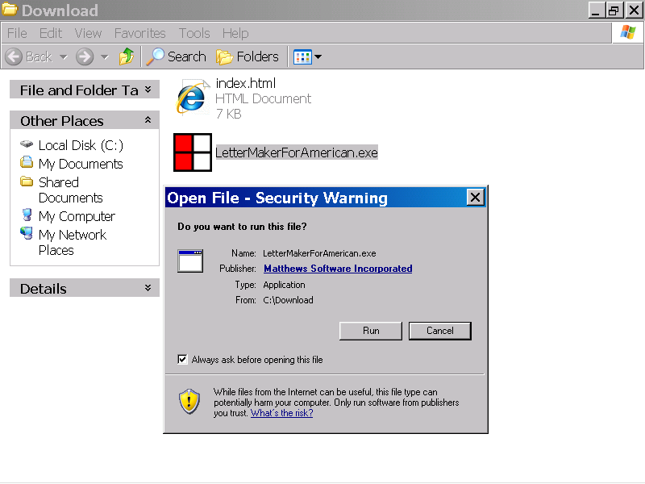
You can select the Matthews Software Incorporated hyperlink, to display more information, about the publisher, Matthews Software Incorporated, and the Microsoft Authenticode Code Signing Certificate, associated with the Letter Maker For American program file.

You can select the Run button, to start up the Letter Maker For American program.

In the illustration below, the hyperlink with the caption, Matthews Software Incorporated”, has been selected. As illustrated below, the Digital Signature Details message box, is now displayed.

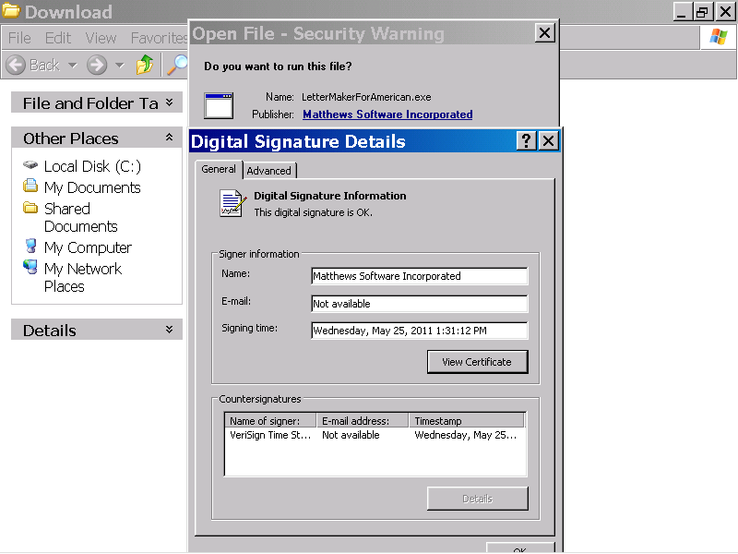

You can select the View Certificate button to display the Microsoft Code Signing Certificate associated with the Letter Maker For American program file.

In the illustration below the View Certificate button, of the Digital Signature Details message box, has been selected. As illustrated below, the Microsoft Authenticode, Code Signing Certificate, associated with the client copy of the program file LetterMakerForAmerican.exe, is now displayed.

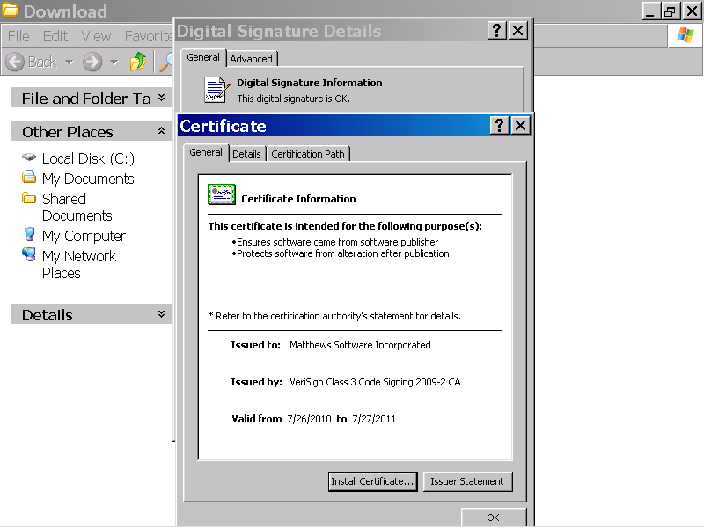

You can select the OK button, to close the Certificate dialog box, and start up the Letter Maker For American program.

In the illustration below, the Certificate message box, has been closed, by selecting the OK button.

As illustrated below, The Digital Signature Details, dialog box is still open, and is now displayed.

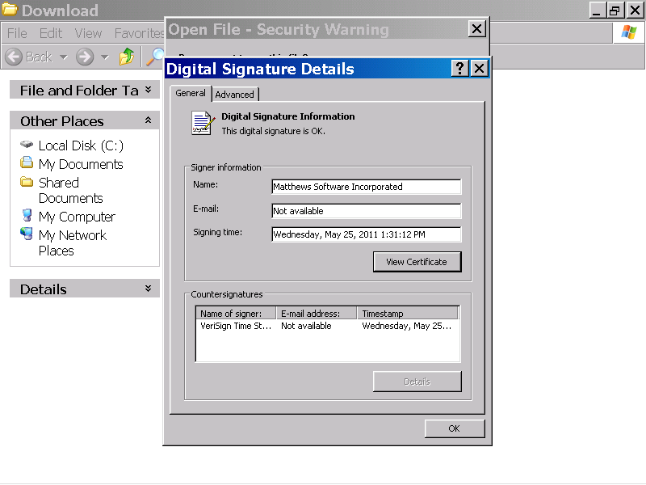
You can select the OK button, to close the Digital Signature Details dialog box, and start up the Letter Maker For American program.

In the illustration below, the OK button of the Digital Signature Details message box has been closed, by selecting the OK button. As illustrated below, the Open File – Security Warning message box is still open and is now displayed.

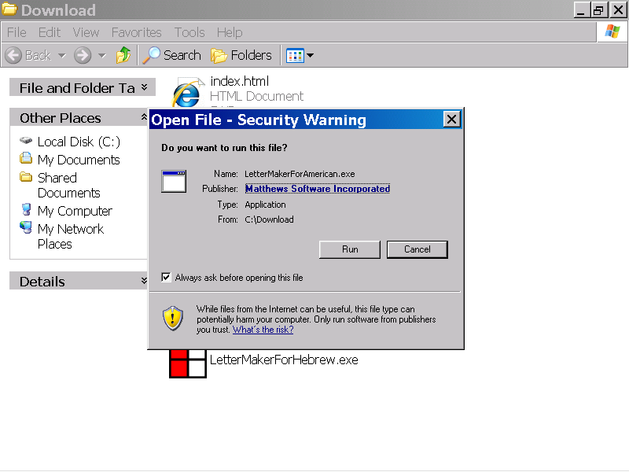

You can select the Run button to start up the Letter Maker For American program.

In the illustration below, the Letter Maker For American program has been started up, by selecting the Run button of the Open File – Security Warning message box.

As illustrated below, The Letter Maker For American User Agreement is now displayed.

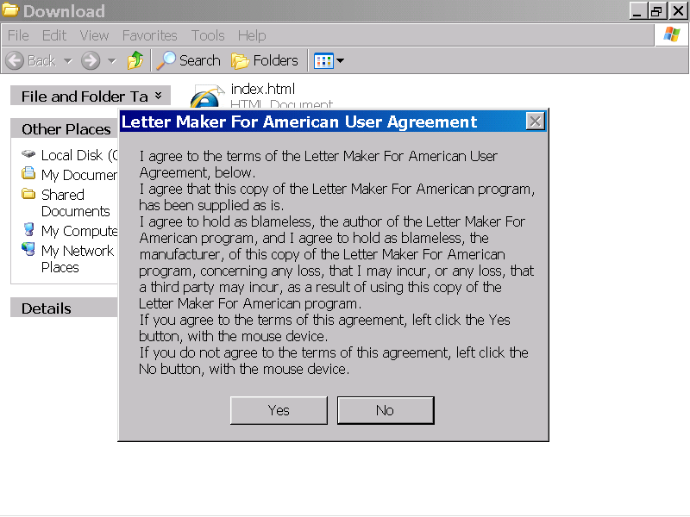
If you agree to the terms of the Letter Maker For American User Agreement, you can left click the Yes button, to start up the Letter Maker For American program.

In the illustration below, the Letter Maker For American program has been started up, by selecting the Yes button of the Letter Maker For American User Agreement message box.

As illustrated below, the program window of the Letter Maker For American program is now displayed at the default size.
Maximize button

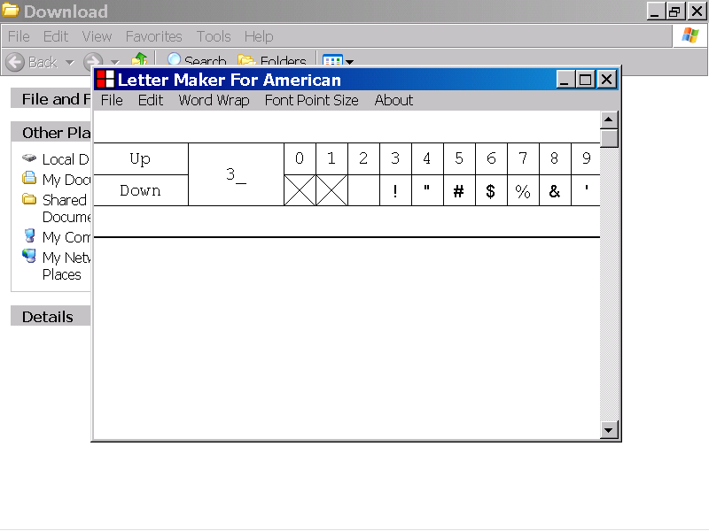
You can select the Maximize button in the upper right corner of the program window to display the Letter Maker For American program window at full screen size.

In the illustration below, the Maximize button in the upper right corner of the Letter Maker For American program window has been selected. As illustrated below, the Letter Maker For American program window is now displayed at full screen size.

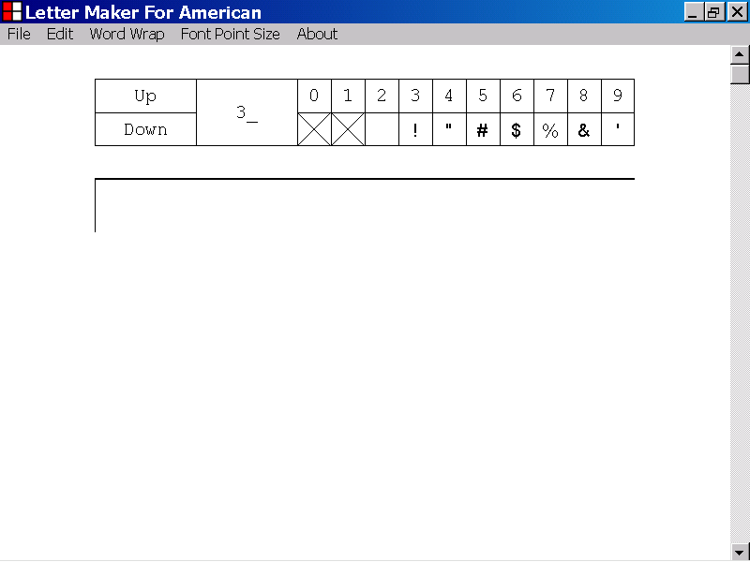

4) The components of the Letter Maker For American program

This section of the documentation provides information about the components of the Letter Maker For American program.

In the illustration below, the Letter Maker program window is displayed at full screen size.

A text document is displayed in the Letter Maker program window.

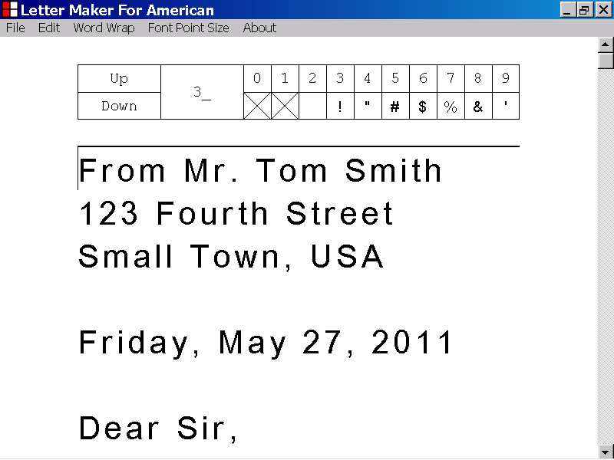

The components of the Letter Maker For American program are the title bar, the Letter Box control, the Text Box control, the vertical scrollbar and the current text document.

The components of the Letter Maker For American program, are identified with labels in the illustration below.
The title bar
The menu bar
The Letter Box control
The Text Box control
The vertical scrollbar control
The current text document

5) The components of the Text Box control

This section of the documentation provides information about the components of the Text Box control.

The Text Box control is one of the components of the Letter Maker For American program.

The Text Box control is identified with a label in the illustration of the Letter Maker For American program window, below.

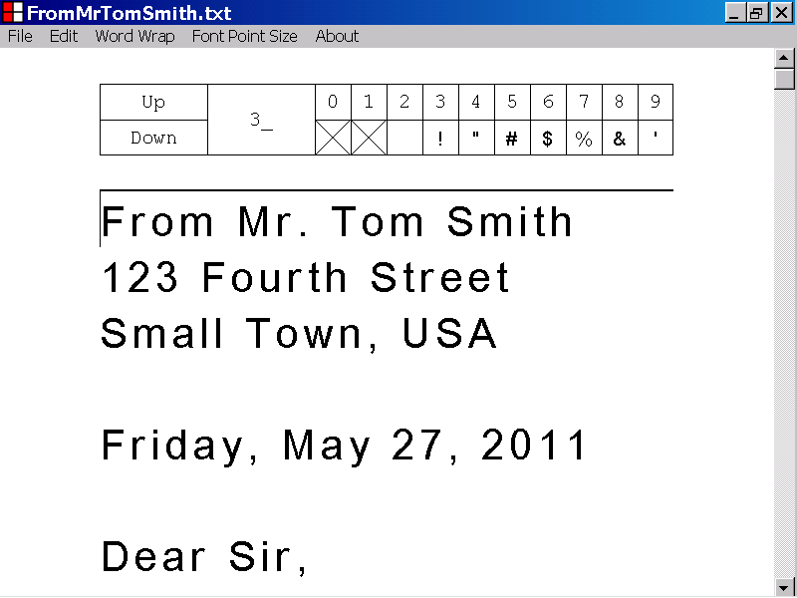
The Text Box control
The components of the Text Box control are the selection line, the caret, the text document, the median page separator line, and the document bottom line. These components are identified with labels in the illustrations below.
The selection line is located at the top of the Text Box control and is identified with a label in the illustration below.

If the selection line is a double thickness line, the Text Box control has keyboard focus.

If the Text Box control has keyboard focus, keyboard input is directed to the capabilities of the Text Box control.

In the illustration below, the selection line is double thickness, which indicates that the Text Box control has keyboard focus.
The selection line is double thickness.

If the selection line is single thickness, the Text Box control does not have keyboard focus.

If the Text Box control does not have keyboard focus, keyboard input is not directed to the capabilities of the Text Box control.

In the illustration below, the selection line is single thickness, which indicates that the Text Box control does not have keyboard focus.
The selection line is single thickness.
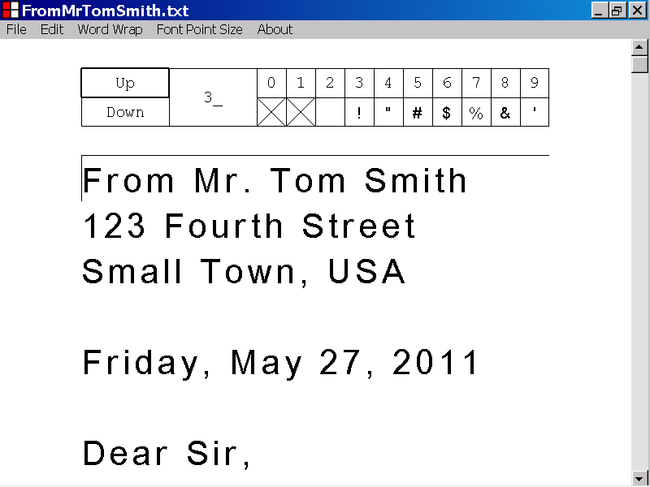

The caret is a single thickness, vertical line, positioned in the Text Box control.

The caret is identified with a label in the illustration below.

When new characters are added to the text document, they are positioned just after the caret.
The caret
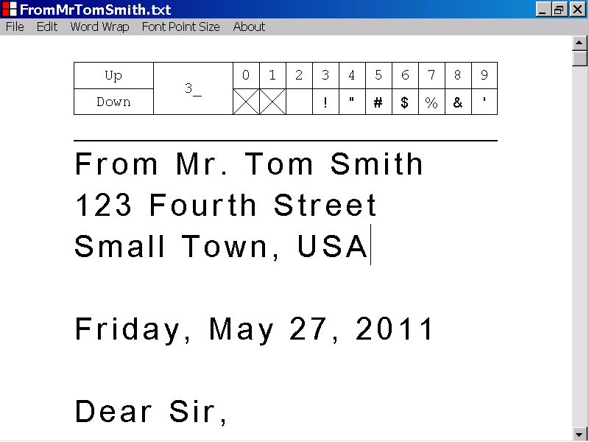

The text document is an array of characters that is displayed in the Text Box control.

The first line, of the current text document, is identified with a label in the illustration below.
The first line of the text document

The characters of the text document can be unselected or selected.

When the capabilities of the Text Box control, act on a text document, sections of unselected text, and sections of selected text, are acted on differently.

A section of unselected text is identified with a label, in the illustration below.

A section of unselected text

A section of selected text is identified with a label in the illustration below.
A section of selected text
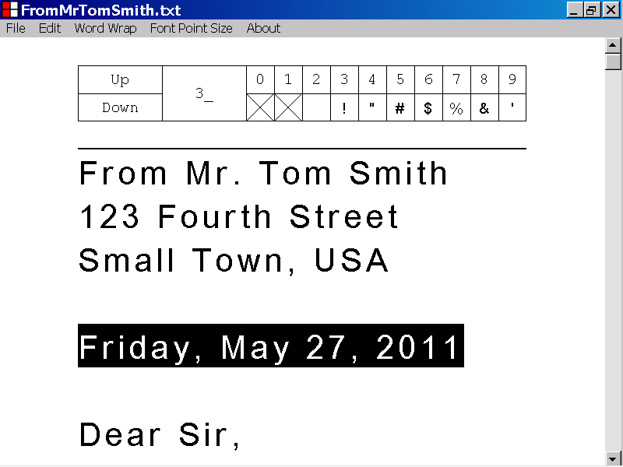

A median page separator line, is a single thickness, horizontal line positioned in the Text Box control.

A median page separator line is positioned between consecutive pages of the text document.

The median page separator line, positioned between the first and second page of the text document, is identified with a label, in the illustration below.

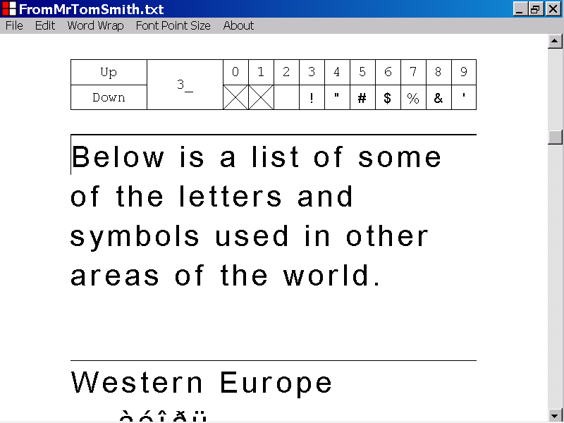
A median page separator line

The document bottom line, is a single thickness, horizontal line positioned at the bottom of the last page of the text document.

The location, of the document bottom line, indicates the position of the bottom of the Text Box control.

The document bottom line is identified with a label in the illustration below.

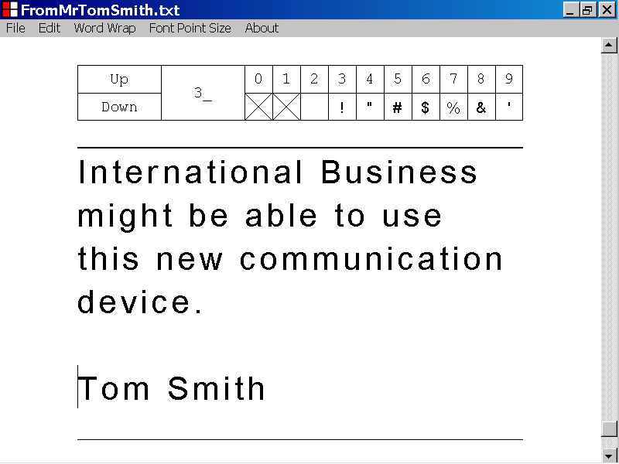
The document bottom line

6) How to set keyboard focus to the Text Box control

This section, of the documentation, provides information about how to set keyboard focus to the Text Box control.

In the illustration below, the selection line of the Text Box control is single thickness, which indicates that the Text Box control does not have keyboard focus.

You can set keyboard focus to the Text Box control, by using one of the techniques, described below.
The selection line is single thickness.
The Text Box control does not have keyboard focus.

If the Text Box control does not have keyboard focus, you can set keyboard focus to the Text Box control, by pressing the Tab key, while holding down the Shift key.

If keyboard focus is set to the Text Box control, by pressing the Tab key, while holding down the Shift key, the current position of the caret is not affected.

In the illustration below, keyboard focus has been set to the Text Box control, by pressing the Tab key, while holding down the Shift key.

The position of the caret has not been affected.
The selection line is double thickness.
The Text Box control has keyboard focus.
The caret position is unchanged

You can also set keyboard focus to the Text Box control, by left clicking the Text Box control, with the mouse device.

If you set keyboard focus to the Text Box control, by left clicking the Text Box control with the mouse device, the caret position is affected by the location of the mouse device left click.

In the illustration below, keyboard focus has been set to the Text Box control, by left clicking the character, “1”, located at the beginning of the second line of the Text Box control.
The selection line is double thickness.
The location of the mouse device left click
The Text Box control has keyboard focus.
New caret position
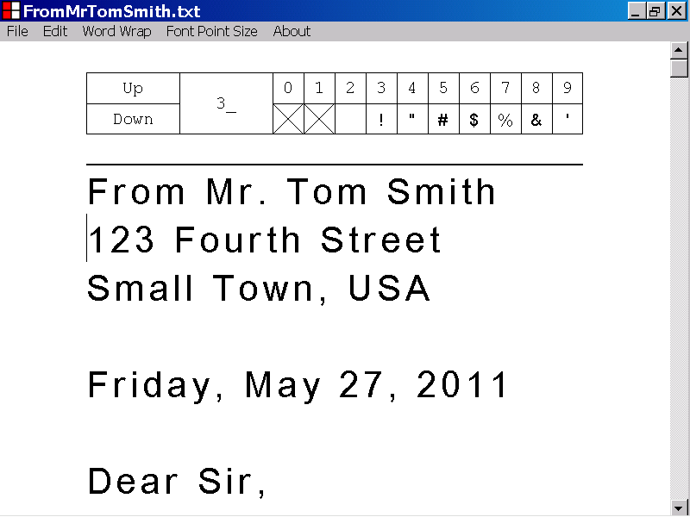

7) How to insert a character into a document, by directing keyboard input to the Text Box control

This section, of the documentation, provides information, about how to enter a character into a document, by directing keyboard input to the Text Box control.

In order to direct keyboard input to the Text Box control, the Text Box control must have keyboard focus.

If the Text Box control has keyboard focus, you can insert a character into a document, by directing keyboard input to the Text Box control, as described below.

When the Letter Maker For American program first starts up, the Text Box control has keyboard focus, as illustrated below.

If the Text Box control has keyboard focus, you can insert a character into the text document, by applying standard typing techniques to the keyboard keys.

If the Text Box control does not have keyboard focus, you can set keyboard focus to the Text Box control, by left clicking the Text Box control with the mouse device.
The selection line is double thickness.
The Text Box control has keyboard focus.
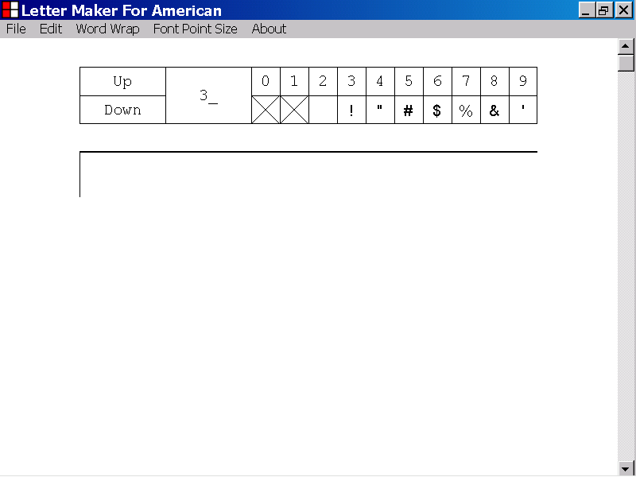

In the illustration below, the letter, “lower case A”, “a”, has been inserted into a new text document, by pressing the keyboard key that displays the symbol, “A”.
The character, “a”, has been inserted into the document.
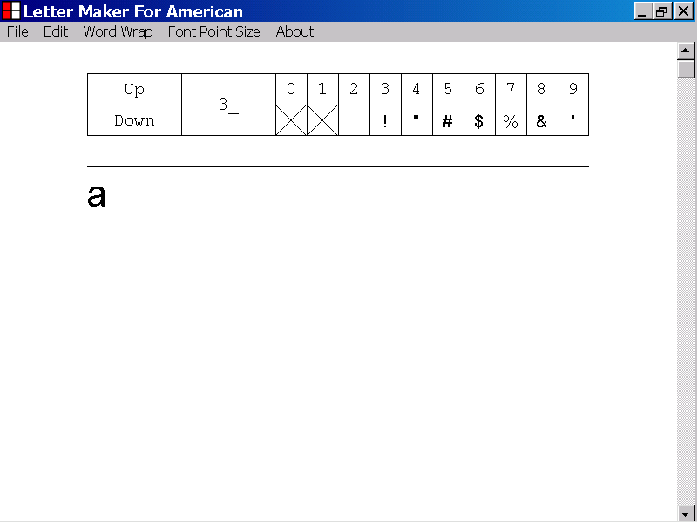

When a new character is inserted into the current document, it is positioned just after the caret.

The caret is a vertical line, displayed by the Text Box control.

The caret position is updated after a character has been inserted into the document, and is positioned just after the newly entered character. The new position of the caret indicates the new insertion point of the Text Box control.

In the illustration below, the caret is identified with a label.
The caret

In the illustration below, the character, “upper case A”, “A”, has been inserted into the document, by pressing the “A” key, while holding down the Shift key.

The “A” character is displayed just to the right of the old position of the caret.

The caret has been repositioned just to the right of the newly added “A” character.
The new position of the caret
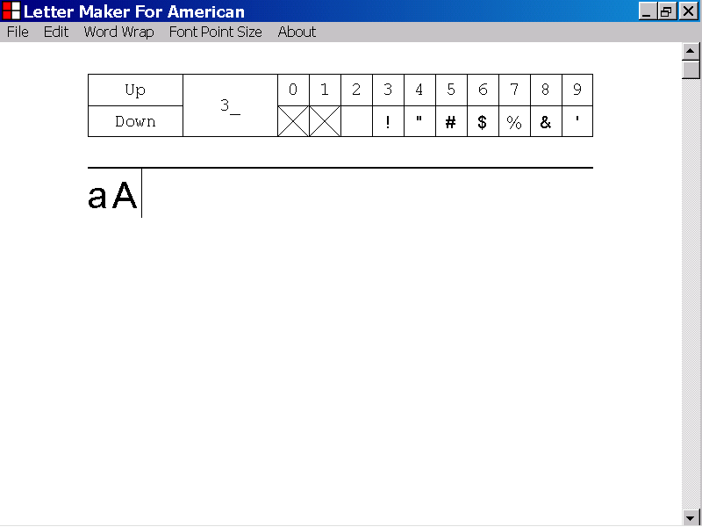
The “A” character has been inserted into the document.

8) How to set the position of the caret in the Text Box control

This section of the documentation provides information about how to set the position of the caret in the Text Box control.

In the illustration below, a text document is displayed in the Text Box control of the Letter Maker For American program.

The position of the caret is identified with a label.

You can set the position of the caret, by using one of the techniques described below.

The caret
If the Text Box control has keyboard focus, you can shift the caret, one character to the right, by pressing the Right Arrow key.

In the illustration below, the caret has been shifted one character to the right, by pressing the Right Arrow key.

If you shift the position of the caret, the position of the scrollbar is automatically updated, if necessary, to ensure that the caret is visible in the Letter Maker For American program window.
The new position of the caret
The old position of the caret
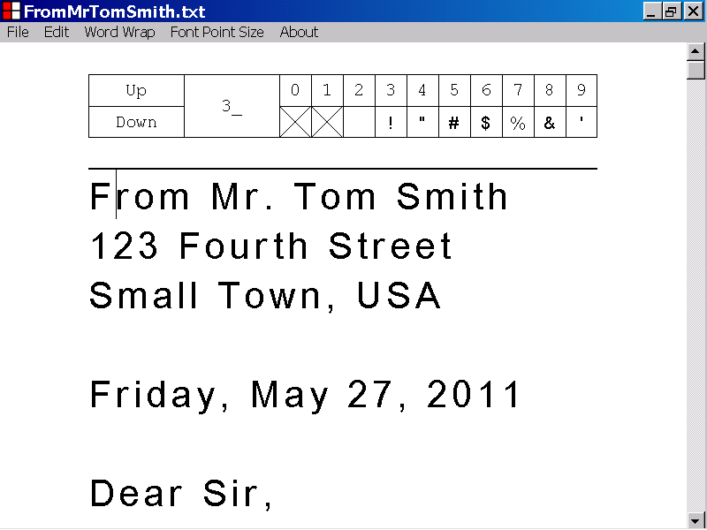

In the illustration below, the caret is positioned at the end of a line, just before the last character of the line.

The last character of the line, illustrated below, is a space character, and is not visible.

When the caret is positioned at the end of a line, just before the last character of that line, you can set the position of the caret to the beginning of the next line of the document, by pressing the Right Arrow key.

If you shift the position of the caret, the position of the scrollbar is automatically updated, if necessary, to ensure that the caret is visible in the Letter Maker For American program window.
A “space” character
The caret
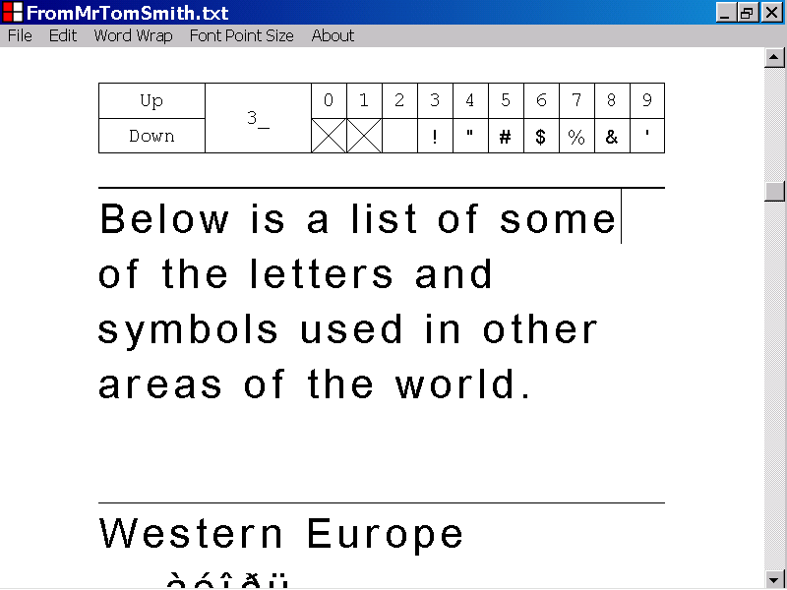
In the illustration below, the caret has been shifted, from the left edge of the last character in a line of the document, to the beginning of the next line of the document, by pressing the Right Arrow key.
The old position of the caret
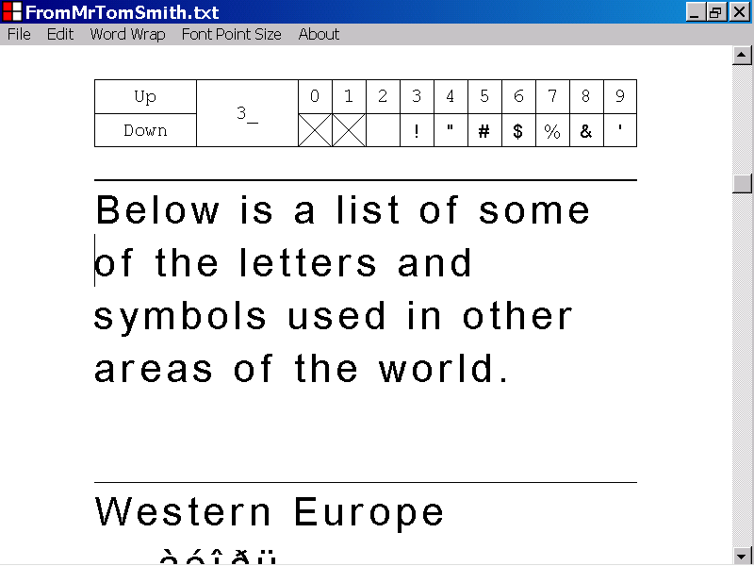
The new position of the caret

In the illustration below, a text document is displayed in the Text Box control of the Letter Maker For American program.

The position of the caret is identified with a label.

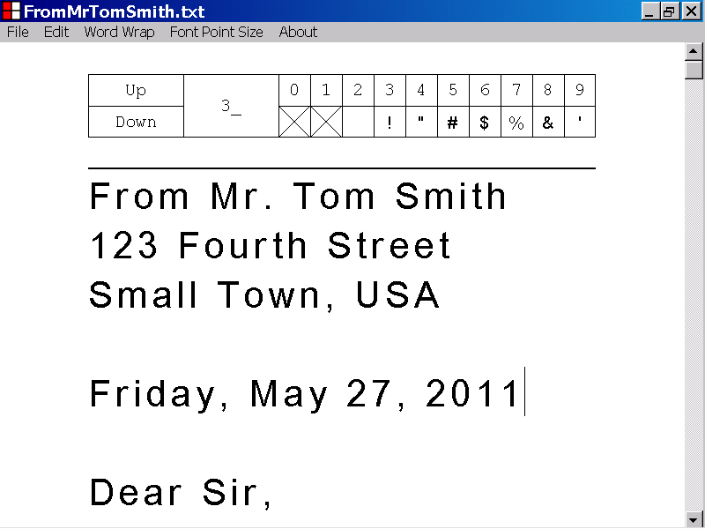
The caret

If the Text Box control has keyboard focus, you can shift the caret, one character to the left, by pressing the Left Arrow key.

If you shift the position of the caret, the position of the scrollbar is automatically updated, if necessary, to ensure that the caret is visible in the Letter Maker For American program window.

In the illustration below, the caret has been shifted, one character to the left, by pressing the Left Arrow key.
The old position of the caret
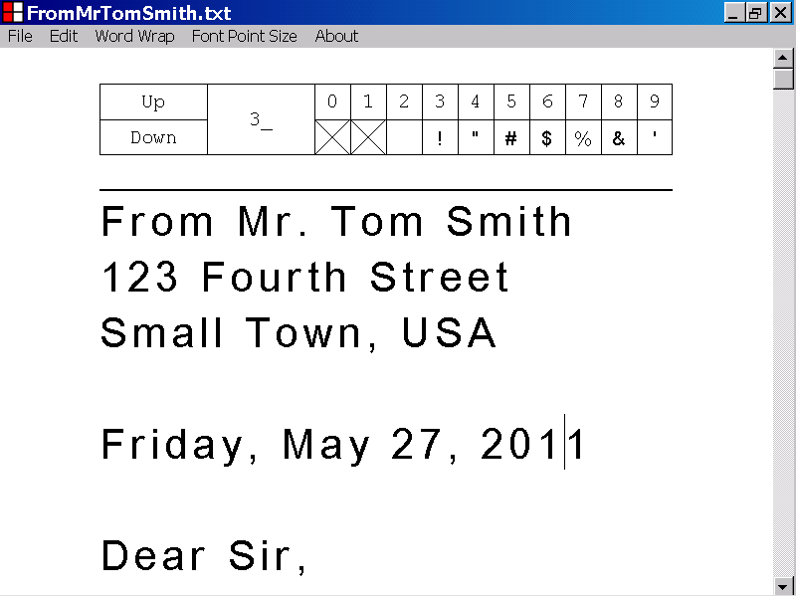
The new position of the caret

In the illustration below, the caret is positioned at the beginning of a line.

If the caret is positioned at the beginning of a line, you can set the position of the caret to the left edge of the last character of the previous line, by pressing the Left Arrow key.

If you shift the position of the caret, the position of the scrollbar is automatically updated, if necessary, to ensure that the caret is visible in the Letter Maker For American program window.

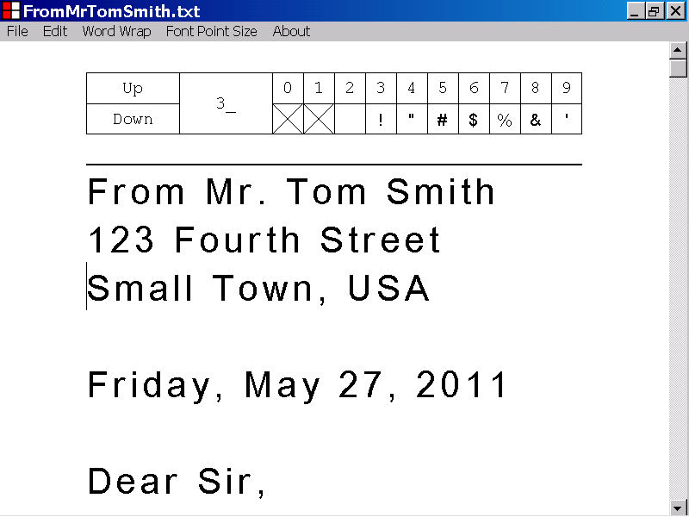
The caret

In the illustration below, the caret has been shifted from the beginning of a line of the document, to the left edge of the last character of the previous line, by pressing the Left Arrow key.

In the illustration below, the last character of the line where the caret has been positioned, is a “carriage return plus line feed” character combination, and is not visible.
A “carriage return plus line feed”, character combination
The old position of the caret
The new position of the caret
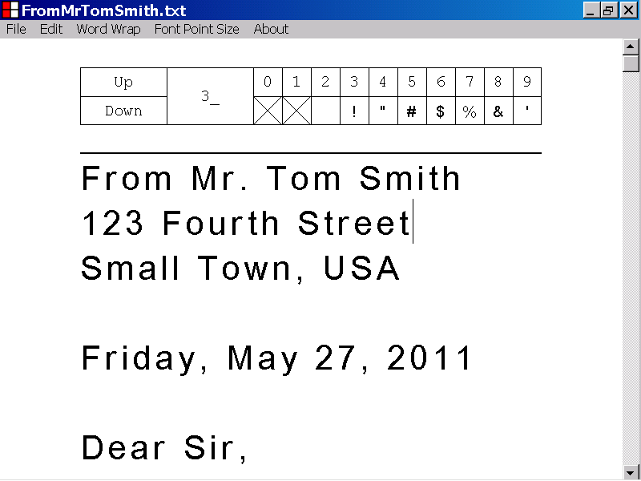

In the illustration below, a text document is displayed in the Text Box control of the Letter Maker For American program.

The position of the caret is identified with a label.
The caret

You can shift the caret, one line down, by pressing the Down Arrow key.

If you shift the position of the caret, the position of the scrollbar is automatically updated, if necessary, to ensure that the caret is visible in the Letter Maker For American program window.

In the illustration below, the position of the caret has been shifted, one line down, by pressing the Down Arrow key.
The old position of the caret
The new position of the caret

In the illustration below, a text document is displayed in the Text Box control of the Letter Maker For American program.

The position of the caret is identified with a label.

The caret

You can shift the caret, one line up, by pressing the Up Arrow key.

If you shift the position of the caret, the position of the scrollbar is automatically updated, if necessary, to ensure that the caret is visible in the Letter Maker For American program window.

In the illustration below, the caret has been shifted, one line up, by pressing the Up Arrow key.
The new position of the caret
The old position of the caret

In the illustration below, a text document is displayed in the Text Box control of the Letter Maker For American program.

The position of the caret is identified with a label.
The caret
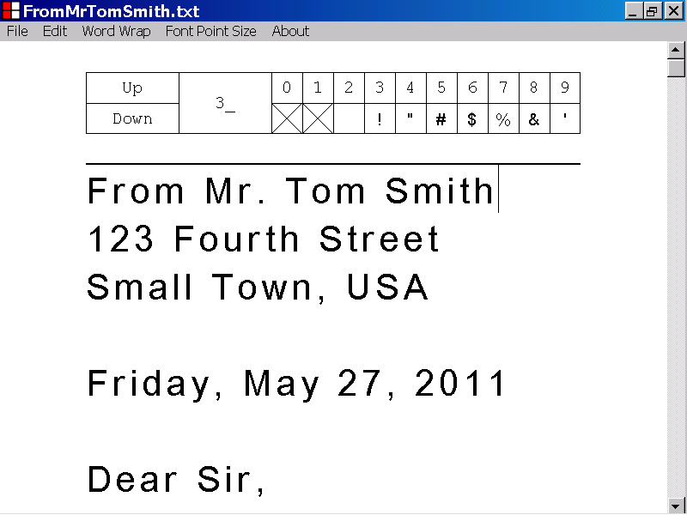

You can shift the caret to the beginning of the current line, by pressing the Home key.

If you shift the position of the caret, the position of the scrollbar is automatically updated, if necessary, to ensure that the caret is visible in the Letter Maker For American program window.

In the illustration below, the caret has been shifted to the beginning of the current line by pressing the Home key.
The new position of the caret
The old position of the caret

In the illustration below, a text document is displayed in the Text Box control of the Letter Maker For American program.

The position of the caret is identified with a label.

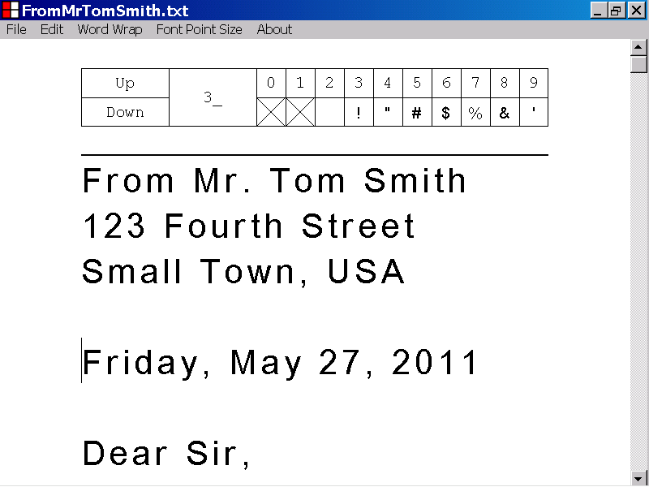
The caret

You can shift the caret to the left edge of the last character of the current line, by pressing the End key.

If you shift the position of the caret, the position of the scrollbar is automatically updated, if necessary, to ensure that the caret is visible in the Letter Maker For American program window.

In the illustration below, the caret has been shifted to the left edge of the last character of the current line, by pressing the End key.

In the illustration below, the last character of the current line is a “carriage return plus line feed”, character combination, and is not visible.
A “carriage return plus line feed”, character combination
The old position of the caret
The new position of the caret

In the illustration below, a text document is displayed in the Text Box control of the Letter Maker For American program.

The position of the caret is identified, with a label.

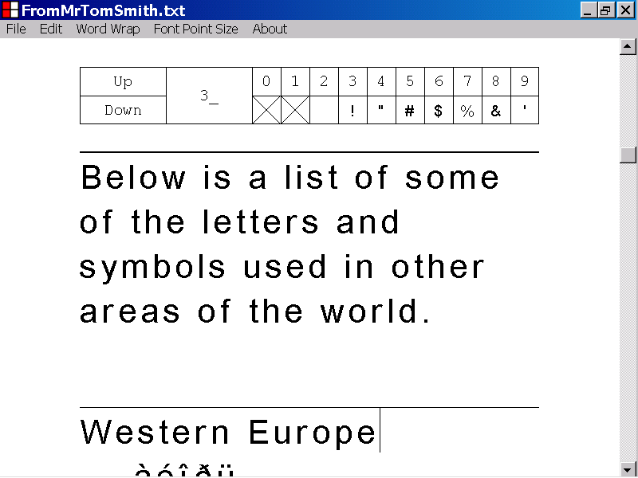
The caret

You can shift the caret to the beginning of the first line of the text document, by pressing the Home key, while holding down the Ctrl key.

If you shift the position of the caret, the position of the scrollbar is automatically updated, if necessary, to ensure that the caret is visible in the Letter Maker For American program window.

In the illustration below, the caret has been shifted to the beginning of the first line of the text document, by pressing the Home key, while holding down the Ctrl key.

The position of the scrollbar has been automatically updated, to ensure that the caret is visible in the Letter Maker For American program window.

The new position of the caret
The new position of the scrollbar
The old position of the scrollbar
In the illustration below, a text document is displayed in the Text Box control of the Letter Maker For American program.

The position of the caret is identified with a label.
The caret

You can shift the caret to the left edge of the last character in the text document, by pressing the End key, while holding down the Ctrl key.

If you shift the position of the caret, the position of the scrollbar is automatically updated, if necessary, to ensure that the caret is visible in the Letter Maker For American program window.

In the illustration below, the caret has been shifted to the left edge of the last character in the text document, by pressing the End key, while holding down the Ctrl key.

A “null” character is located just after the current position of the caret, and is not visible.

The scrollbar position has been updated automatically to ensure that the caret is visible in the Letter Maker For American program window.
The old position of the scrollbar
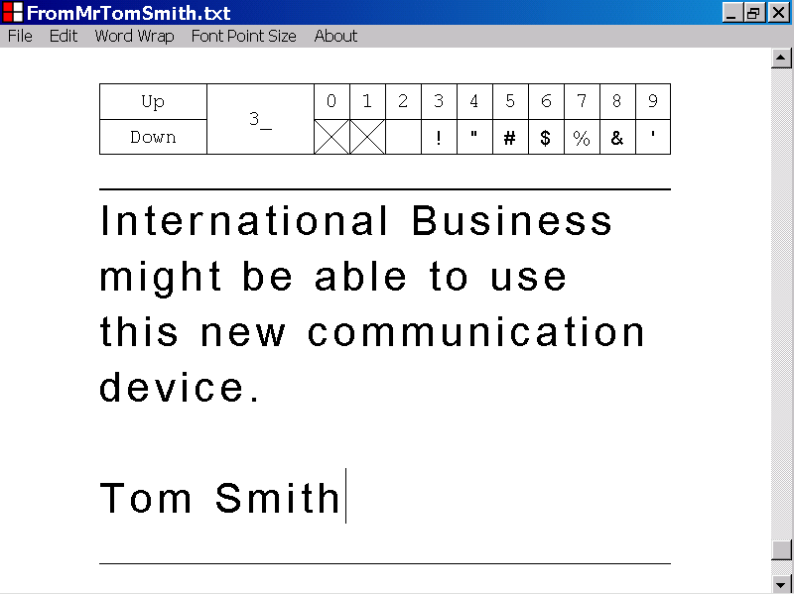
The new position of the caret
A “null” character
The new position of the scrollbar

In the illustration below, a text document is displayed in the Text Box control of the Letter Maker For American program.

The position of the caret is identified with a label.

The caret

You can shift the caret, to the beginning of the line, approximately one screen down, by pressing the Page Down key.

The number of lines, shifted, is based on the number of lines of the text document, that can currently be seen in the Letter Maker For American program window, at one time.

If you shift the position of the caret, the position of the scrollbar is automatically updated, if necessary, to ensure that the caret is visible in the Letter Maker For American program window.

In the illustration below, the caret has been shifted to the beginning of the line, approximately one screen down, by pressing the Page Down key.

The position of the scrollbar has been automatically updated, to ensure that the caret is visible in the Letter Maker For American program window.
The old postion of the scrollbar
The old position of the caret
The new position of the caret
The new position of the scrollbar
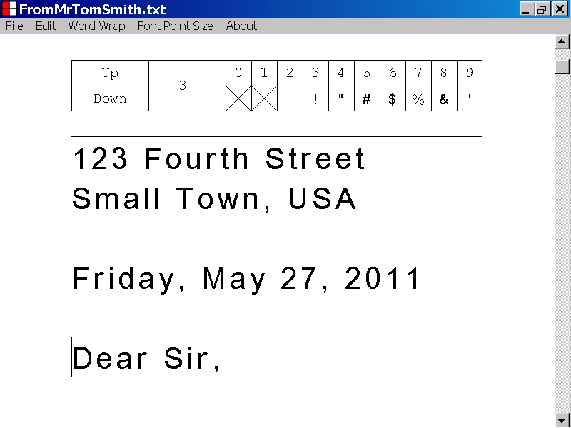

In the illustration below, a text document is displayed in the Text Box control of the Letter Maker For American program.

The position of the caret is identified with a label.

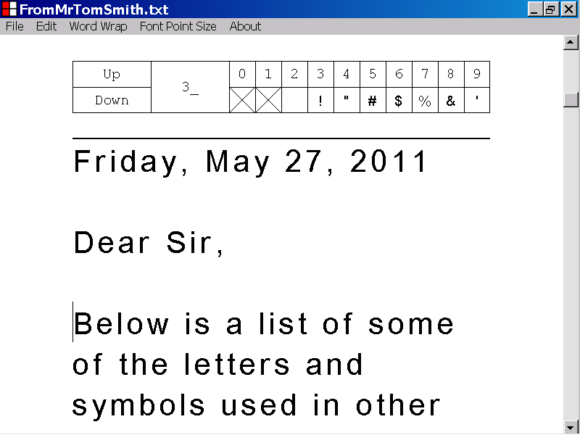
The caret
The caret

You can shift the caret, to the beginning of the line, approximately one screen up, by pressing the Page Up key.

The number of lines, shifted, is based on the number of lines, of the text document, that can currently be seen in the Letter Maker For American program window, at one time.

If you shift the position of the caret, the position of the scrollbar is automatically updated, if necessary, to ensure that the caret is visible in the Letter Maker For American program window.

In the illustration below, the caret has been shifted to the beginning of the line, approximately one screen up, by pressing the Page Up key.

The position of the scrollbar has been automatically updated, to ensure that the caret is visible in the Letter Maker For American program window.
The new position of the caret
The new position of the scrollbar
The old position of the caret
The old position of the scrollbar
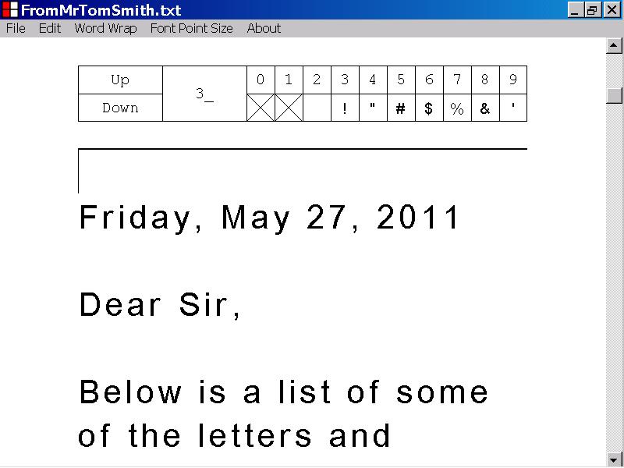

In the illustration below, a text document is displayed in the Text Box control of the Letter Maker For American program.

The position of the caret is identified with a label.

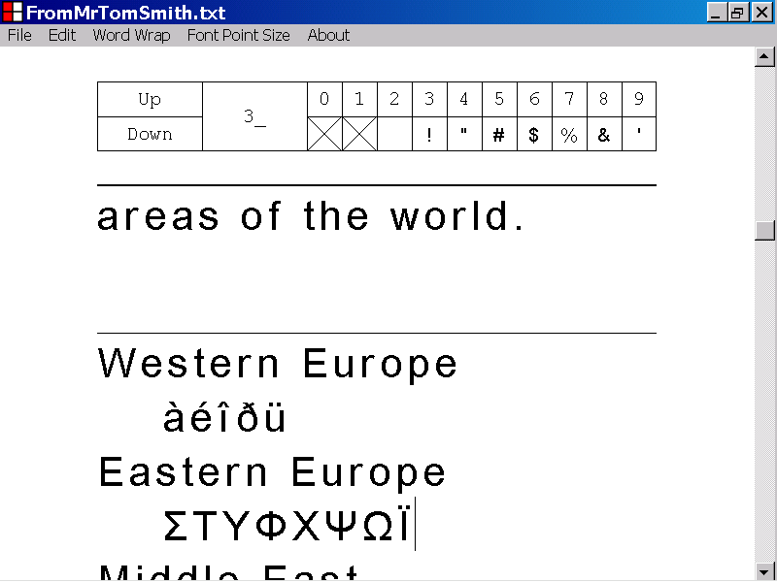
The caret

In the illustration above, the caret is not positioned at the beginning of the first line of the current page of the text document.

If the caret is not positioned, at the beginning of the first line of the current page, of the text document, you can shift the caret to the beginning of the first line of the current page of the text document, by pressing the Page Up key, while holding down the Ctrl key.

If you shift the position of the caret, the position of the scrollbar is automatically updated, if necessary, to ensure that the caret is visible in the Letter Maker For American program window.

In the illustration below, the caret has been shifted, to the beginning of the first line of the current page of the text document, by pressing the Page Up key, while holding down the Ctrl key.

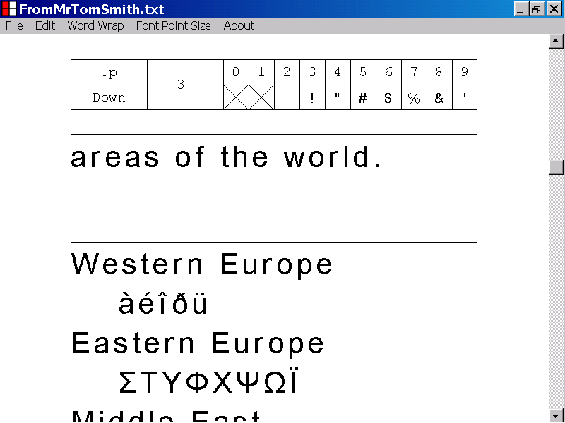
The new position of the caret
The old position of the caret

In the illustration below, a text document is displayed in the Text Box control of the Letter Maker For American program window.

The caret is positioned at the beginning of the first line of the current page of the text document.

The position of the caret is identified with a label.

The caret

In the illustration above, the caret is positioned at the beginning of the first line of the current page of the text document.

If the caret is positioned at the beginning of the first line of the current page of the text document, you can shift the caret to the beginning of the first line of the previous page of the text document, by pressing the Page Up key, while holding down the Ctrl key.

If you shift the position of the caret, the position of the scrollbar is automatically updated, if necessary, to ensure that the caret is visible in the Letter Maker For American program window.

In the illustration below, the caret has been shifted to the beginning of the first line of the previous page of the text document, by pressing the Page Up key, while holding down the Ctrl key.

The position of the scrollbar has been automatically updated, to ensure that the caret is visible in the Letter Maker For American program window.
The new position of the scrollbar
The new position of the caret
The old position of the scrollbar

In the illustration below, a text document is displayed in the Text Box control of the Letter Maker For American program.

The position of the caret is identified with a label.
The caret

In the illustration above, the caret is not positioned on the last page of the text document.

If the caret is not positioned on the last page of the text document, you can shift the caret to the beginning of the first line of the next page of the text document, by pressing the Page Down key while holding down the Ctrl key.

If you shift the position of the caret, the position of the scrollbar is automatically updated, if necessary, to ensure that the caret is visible in the Letter Maker For American program window.

In the illustration below, the caret has been shifted to the beginning of the first line of the next page of the text document, by pressing the Page Down key, while holding down the Ctrl key.

The position of the scrollbar has been automatically updated, to ensure that the caret is visible in the Letter Maker For American program window.
The old position of the scrollbar
The new position of the caret
The new position of the scrollbar
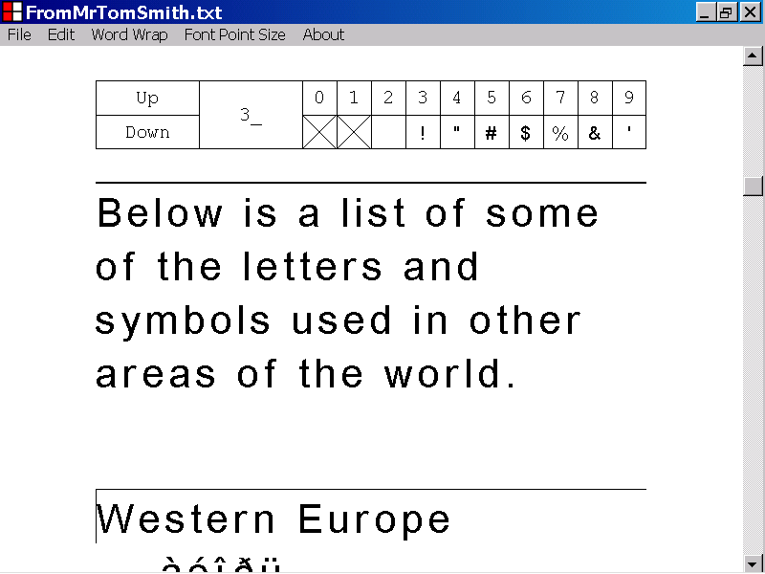

In the illustration below, a text document is displayed in the Text Box control of the Letter Maker For American program window.

The caret is positioned on the last page of the text document, but not on the last line of the text document.

The position of the caret is identified with a label.
The caret
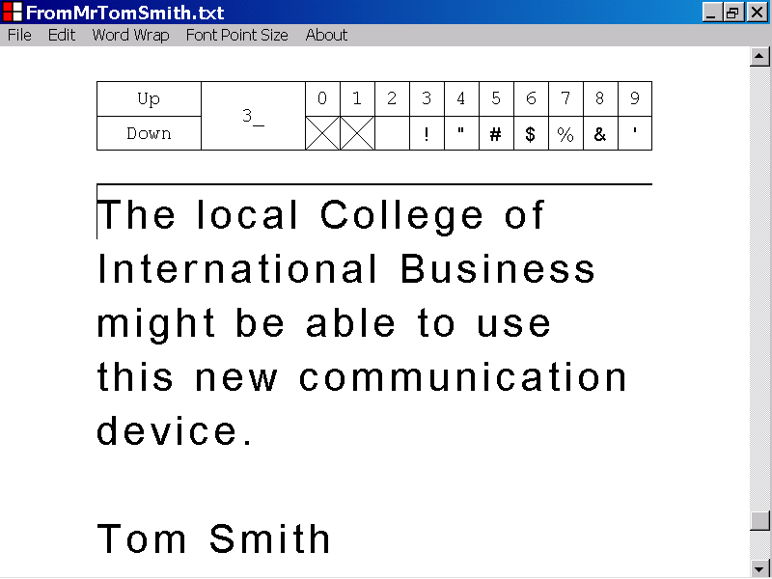
The last line of the text document

In the illustration above, the caret is positioned on the last page of the text document, but not on the last line of the text document.

If the caret is positioned on the last page of the text document, but not on the last line of the text document, you can shift the caret to the beginning of the last line of the text document, by pressing the Page Down key, while holding down the Ctrl key.

If the caret is positioned on the last line of the text document, pressing the Page Down key while holding down the Ctrl key, will not shift the position of the caret.

If you shift the position of the caret, the position of the scrollbar is automatically updated, if necessary, to ensure that the caret is visible in the Letter Maker For American program window.

In the illustration below, the caret has been shifted to the beginning of the last line of the text document, by pressing the Page Down key, while holding down the Ctrl key.

The new position of the caret
The old position of the scrollbar
The document bottom line

The new position of the scrollbar

In the illustration below, a text document is displayed in the Text Box control of the Letter Maker For American program.

The position of the caret is identified with a label.
The caret

You can shift the caret to the left edge of a character in the text document, by left clicking the character with the mouse device.

If you shift the position of the caret, the position of the scrollbar is automatically updated, if necessary, to ensure that the caret is visible in the Letter Maker For American program window.

In the illustration below, the caret has been shifted to the left edge of the “upper case letter S”, in the first line of the text document, by left clicking the letter with the mouse device.
The Location of the mouse device left click
The new position of the caret

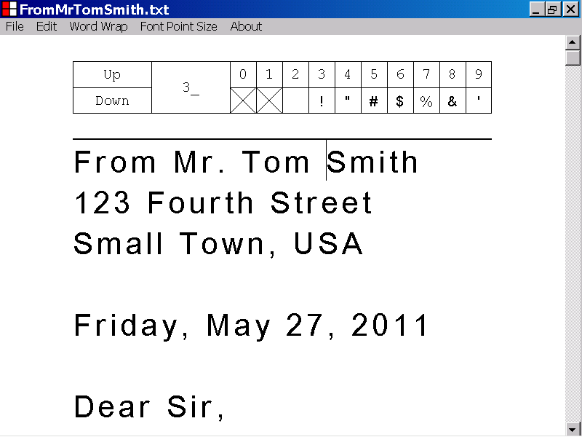

In the illustration below, a text document is displayed in the Text Box control of the Letter Maker For American program.

The position of the caret is identified with a label.
The caret

You can shift the caret to the left edge of the last character in a line of the text document, by left clicking the Text Box control, to the right of the last character in that line.

If you shift the position of the caret, the position of the scrollbar is automatically updated, if necessary, to ensure that the caret is visible in the Letter Maker For American program window.

In the illustration below, the caret has been shifted to the left edge of the last character in a line of the text document, by left clicking the Text Box control, to the right of the last character in that line.

In the illustration below, the last character, in the line, where the caret has been positioned, is a “carriage return plus line feed”, character combination, and is not visible.
The old position of the caret
The new position of the caret
The location of the mouse device left click
A “carriage return plus line feed”, character combination

In the illustration below, a text document is displayed in the Text Box control of the Letter Maker For American program.

The position of the caret is identified with a label.
The caret
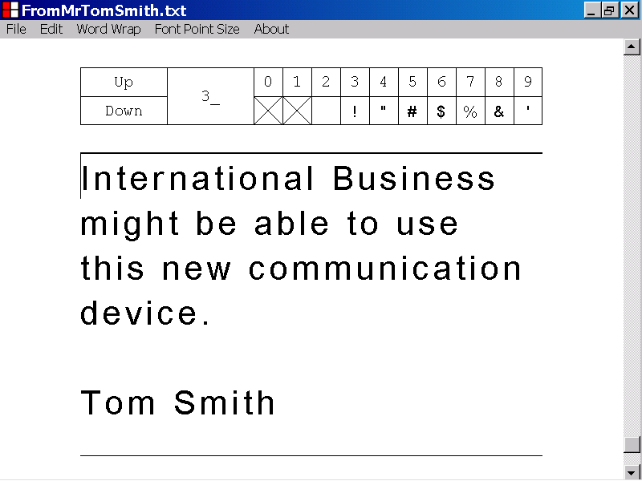

You can shift the caret to the left edge of the last character in the text document, by left clicking the Text Box control, below the last line of the text document.

If you shift the position of the caret, the position of the scrollbar is automatically updated, if necessary, to ensure that the caret is visible in the Letter Maker For American program window.

In the illustration below, the caret has been shifted to the left edge of the last character in the document, by left clicking the Text Box control, below the last line of the text document.

The last character of the text document, which is just to the right of the caret, is a “null character” and is not visible.

A
The old position of the caret
The new position of the caret
A “null” character
The location of the mouse device left click
9) How to insert a new line into a text document, by pressing the Enter key

This section of the documentation provides information about how to insert a new line into a text document, by pressing the Enter key.

In the illustration below, a text document is displayed in the Text Box control of the Letter Maker For American program.

The caret is positioned at the left edge of the last character of the document and is identified with a label.

The last character of the document is a “null” character, and is not visible.
The caret
A “null” character
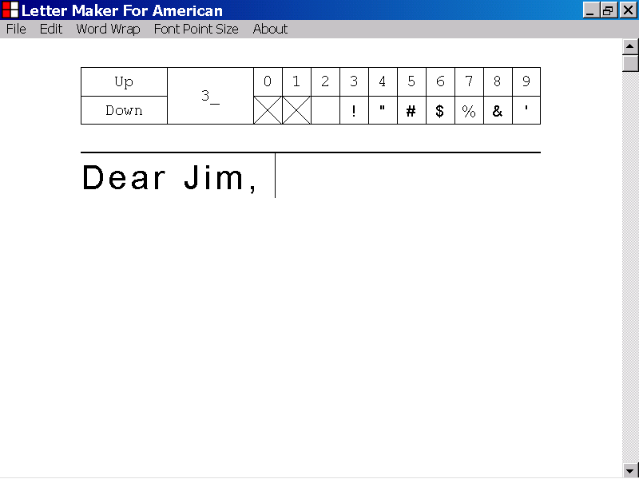
In the illustration above, the Text Box control has keyboard focus.

If the Text Box control has keyboard focus, you can insert a new line into the text document, by pressing the Enter key.

If the Text Box control does not have keyboard focus, you can set keyboard focus to the Text Box control, without affecting the position of the caret, by pressing the Tab key, while holding down the Shift key.

If the Text Box control has keyboard focus, you can insert a “carriage return plus line feed” character combination into the text document, just after the caret, by pressing the Enter key.

The “carriage return plus line feed” character combination designates the end of the line of the text document, where the character combination is located.

If you insert a “carriage return plus line feed” character combination into the text document, just after the caret, the caret is shifted to the beginning of the next line of the text document.

If you shift the position of the caret, the position of the scrollbar is automatically updated, if necessary, to ensure that the caret is visible in the Letter Maker For American program window.

In the illustration below, a new line has been entered into the text document, by pressing the Enter key.

A “carriage return plus line feed” character combination, has been entered into the text document, just to the right of the old position of the caret.

The “carriage return plus line feed” character combination designates the end of the first line of the text document, and is not visible.

The caret has been shifted to the beginning of the next line of the text document.
The old position of the caret
The “carriage return plus line feed” character combination
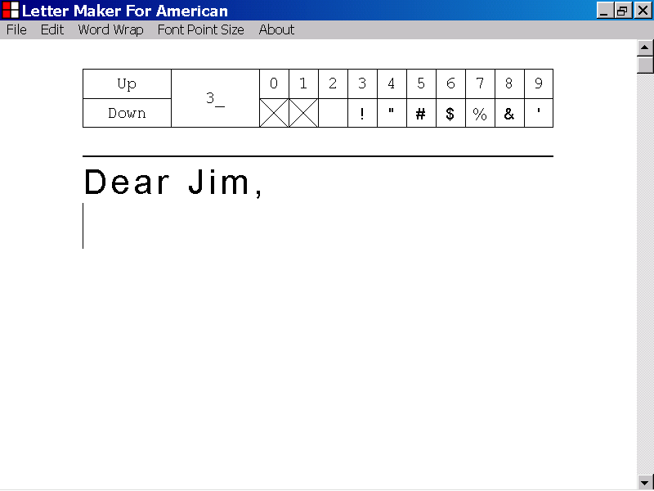
The new position of the caret

10) How to insert four consecutive spaces into a text document, by pressing the Tab key.

This section of the documentation provides information about how to insert four consecutive spaces into a text document, by pressing the Tab key.

In the illustration below, a text document is displayed in the Text Box control of the Letter Maker For American program.

The position of the caret is identified with a label.
The caret
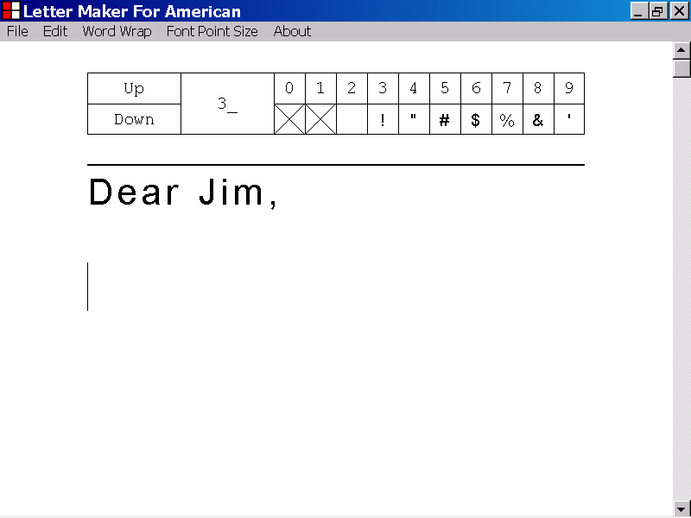

In the illustration above, the Text Box control has keyboard focus.

If the Text Box control has keyboard focus, you can insert four consecutive spaces into the text document, by pressing the Tab key.

If the Text Box control does not have keyboard focus, you can set keyboard focus to the Text Box control, without affecting the position of the caret, by pressing the Tab key, while holding down the Shift key.

If you insert four consecutive spaces into the text document, just to the right of the caret, the caret will be repositioned just after the last “space” character inserted.

If you shift the position of the caret, the position of the scrollbar is automatically updated, if necessary, to ensure that the caret is visible in the Letter Maker For American program window.

In the illustration below, four consecutive spaces have been inserted into the text document, by pressing the Tab key.

The caret has been repositioned just after the last “space” character inserted.
Four consecutive spaces
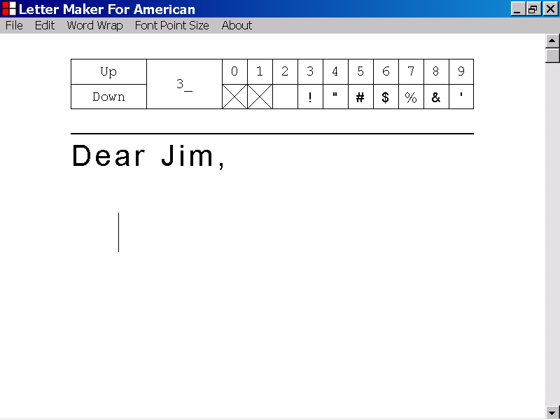
The new position of the caret
The old position of the caret

11) How to delete a character of a text document, by pressing the Delete key

This section of the documentation provides information about how to delete a character of a text document, by pressing the Delete key.

In the illustration below, a text document is displayed in the Text Box control of the Letter Maker For American program window.

The caret is positioned just before the “F” character at the beginning of the fifth line of the text document, and is identified with a label.
The caret
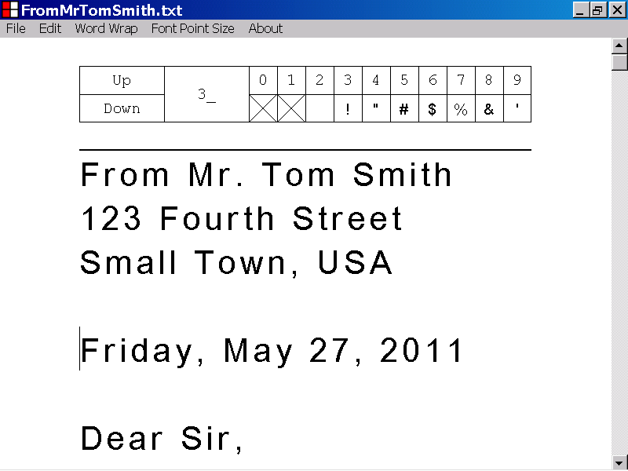

In the illustration above, the Text Box control has keyboard focus.

If the Text Box control has keyboard focus, you can delete the character, just after the caret, by pressing the Delete key.

If the Text Box control does not have keyboard focus, you can set keyboard focus to the Text Box control, without affecting the position of the caret, by pressing the Tab key, while holding down the Shift key.

If you shift the position of the caret, the position of the scrollbar is automatically updated, if necessary, to ensure that the caret is visible in the Letter Maker For American program window.

In the illustration below, the “F” character, just after the caret, at the beginning of the fifth line of the text document, has been deleted by pressing the Delete key.

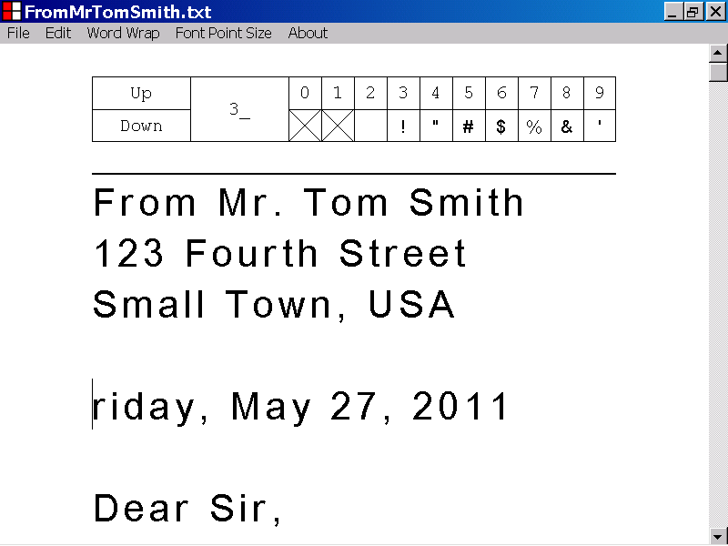
The caret

12) How to delete a character of a text document, by pressing the Backspace key

This section of the documentation provides information about how to delete a character of a text document, by pressing the Backspace key.

In the illustration below, a text document is displayed in the Text Box control of the Letter Maker For American program window.

The caret is positioned just after the “F” character at the beginning of the fifth line of the text document, and is identified with a label.

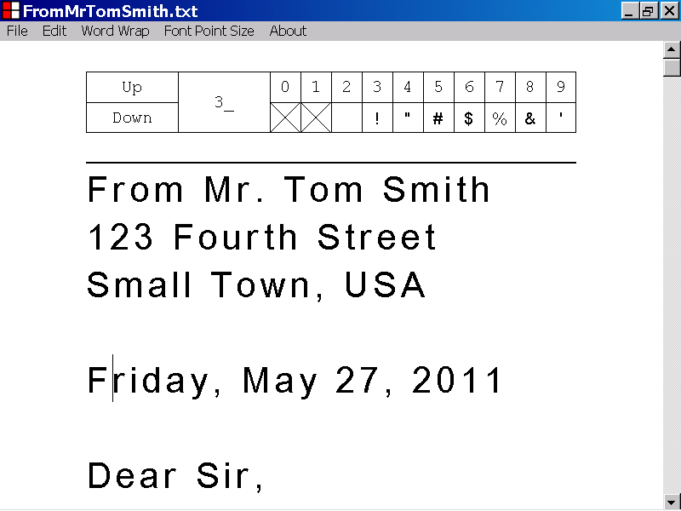
The caret

In the illustration above, the Text Box control has keyboard focus.

If the Text Box control has keyboard focus, you can delete the character, just before the caret, by pressing the Backspace key.

If the Text Box control does not have keyboard focus, you can set keyboard focus to the Text Box control, without affecting the position of the caret, by pressing the Tab key, while holding down the Shift key.

If you delete the character of a text document, just before the caret, by pressing the Backspace key, the caret will be repositioned just before the old position of the character that was deleted.

If you shift the position of the caret, the position of the scrollbar is automatically updated, if necessary, to ensure that the caret is visible in the Letter Maker For American program window.

In the illustration below, the “F” character, just before the caret at the beginning of the fifth line of the text document, has been deleted, by pressing the Backspace key.

The caret

13) The components of the Letter Box control

This section of the documentation provides information about the components of the Letter Box control.

The Letter Box control is one of the components of the Letter Maker For American program.

The Letter Box control is identified with a label in the illustration of the Letter Maker For American program window, below.
The Letter Box control
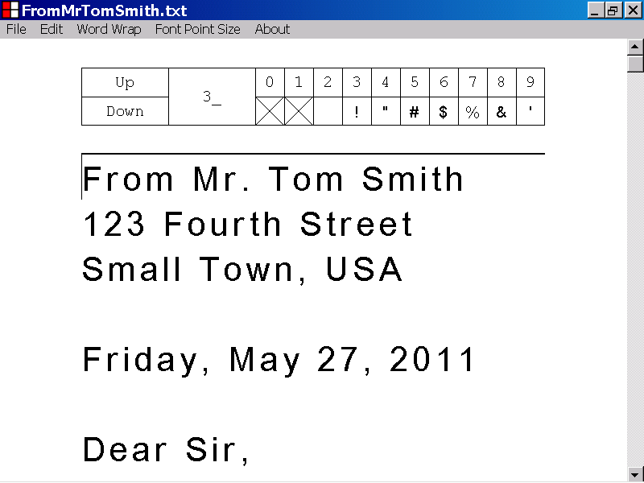

The components of the Letter Box control are the Up button, the Down button, the Line Index label, ten Letter Display labels and ten Letter Display buttons.

These components are identified with labels in the illustrations below.

The Letter Box control, of the Letter Maker For American program, displays the letters of the Unicode Character Set.

The Unicode Character Set is a collection of the letters, used by the many languages, known to the computer industry.

Each letter of the Unicode Character Set, has a character index and a visual representation.

The letters displayed by the Letter Box control of the Letter Maker For American program, have character indexes that range in value from 32 to 65535.

The letters displayed by the Letter Box control are displayed ten at a time, in a row of Letter Display buttons.

The letters displayed by the Letter Box control, can be inserted into a text document by using the keyboard or the mouse device.

The letters displayed by the Letter Box control, can be scrolled by using the keyboard or the mouse device.

The Up button, of the Letter Box control, is located at the upper left corner of the Letter Box control, and is identified with a label in the illustration below.

You can use the Up button to scroll the letters displayed by the Letter Box control.
The Up button

The Down button, of the Letter Box control, is located in the lower left corner of the Letter Box control, and is identified with a label in the illustration below.

You can use the Down button to scroll the letters displayed by the Letter Box control.
The Down button

The Line Index label, of the Letter Box control, is located just to the right of the Up button and the Down button, and is identified with a label in the illustration below.

The Line Index label displays the line index value of the row of letters currently displayed by the Letter Box control.

In the illustration below the Line Index label displays the line index value, “3_”.

In the illustration below, the row of letters displayed by the Letter Box control, have character index values between 30 and 39.
The Line Index label

The Letter Display labels, of the Letter Box control, are located in the upper right corner of the Letter Box control, and are identified with a label in the illustration below.

There are ten Letter Display labels, that display index values between 0 and 9.

Each Letter Display label displays the index value of the Letter Display button directly below it.

You can determine the character index value of a letter displayed by a Letter Display button, by replacing the “underscore” character, “_”, of the current line index value, with the index value of the Letter Display button.
The current line index value is “3_”.
The Letter Display labels
This letter has character index value 38.

The Letter Display buttons, of the Letter Box control, are located in the lower right corner of the Letter Box control, and are identified with a label in the illustration below.

There are ten Letter Display buttons, that display the visual representation of a range of letters that belong to the Unicode Character Set.

You can insert the letter displayed by a Letter Display button, into a text document, by using the keyboard or the mouse device.
The Letter Display buttons

14) How to set keyboard focus to the Letter Box control

This section of the documentation provides information about how to set keyboard focus to the Letter Box control.

If the Letter Box control has keyboard focus, one of the buttons of the Letter Box control, is the selected button of the Letter Box control.

Keyboard input is directed to the capabilities of the selected button of the Letter Box control.

The selected button of the Letter Box control displays a double thickness border.

If the Letter Box control does not have keyboard focus, none of the buttons of the Letter Box control display a double thickness border.

In the illustration below, none of the buttons of the Letter Box control, display a double thickness border, which indicates that the Letter Box control does not have keyboard focus.

You can set keyboard focus to the Letter Box control, using one of the techniques described below.
The Letter Box control does not have keyboard focus.

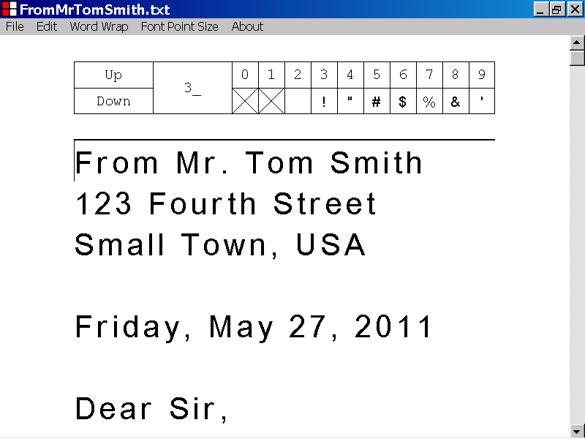

If the Letter Box control does not have keyboard focus, you can set keyboard focus to the Letter Box control by pressing the Tab key, while holding down the Shift key.

If you set keyboard focus to the Letter Box control, by pressing the Tab key, while holding down the Shift key, the Up button becomes the selected button of the Letter Box control, but the capabilities of the Up button are not triggered.

In the illustration below, keyboard focus has been set to the Letter Box control, by pressing the Tab key, while holding down the Shift key.

The Up button has become the selected button of the Letter Box control and keyboard input will now be directed to the capabilities of the Up button.

The scrolling capabilities of the Up button have not been triggered.
The Up button is the selected button of the Letter Box control.
The Letter Box control has keyboard focus.
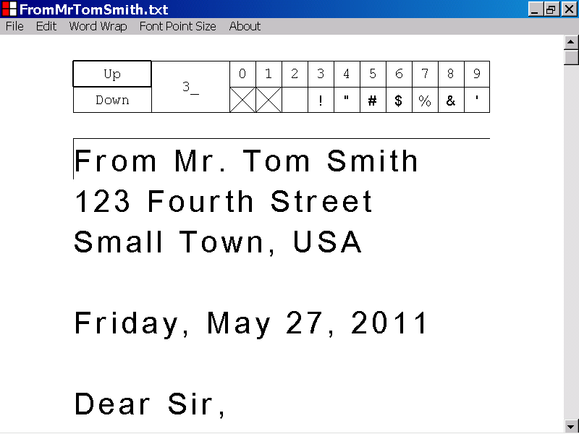

In the illustration below, none of the buttons of the Letter Box control display a double thickness border, which indicates that the Letter Box control does not have keyboard focus.

You can set keyboard focus to the Letter Box control, by left clicking the Up button with the mouse device.

If you set keyboard focus to the Letter Box control, by left clicking the Up button with the mouse device, the capabilities of the Up button are triggered, and the Up button becomes the selected button of the Letter Box control.
The Letter Box control does not have keyboard focus.

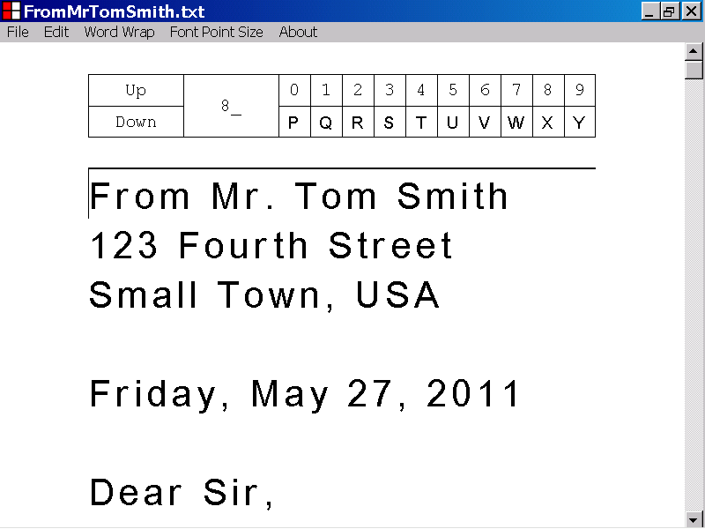

In the illustration below, keyboard focus has been set to the Letter Box control, by left clicking the Up button of the Letter Box control.

The scrolling capabilities of the Up button have been triggered.

The Up button has become the selected button of the Letter Box control and keyboard input will now be directed to the capabilities of the Up button.
The Up button is the selected button of the Letter Box control.
The Letter Box control has been scrolled upward.
The Letter Box control has keyboard focus.
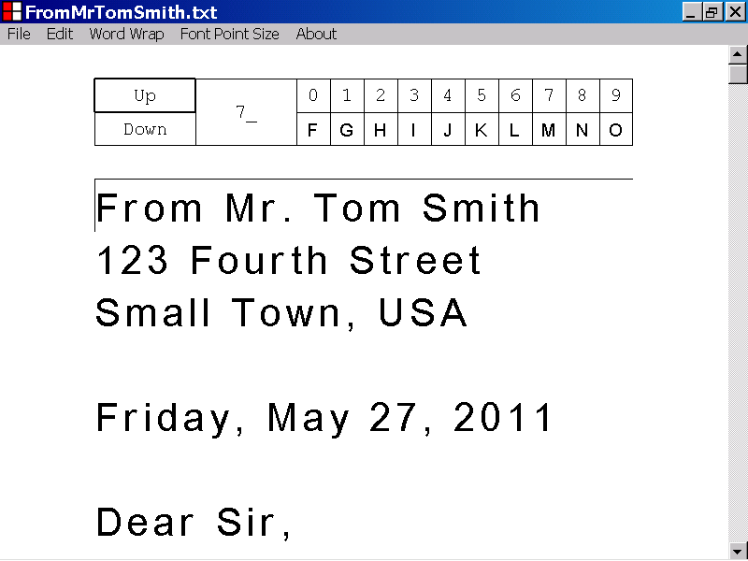

In the illustration below, none of the buttons of the Letter Box control, display a double thickness border, which indicates that the Letter Box control does not have keyboard focus.

You can set keyboard focus to the Letter Box control, by left clicking the Down button, with the mouse device.

If you set keyboard focus to the Letter Box control, by left clicking the Down button with the mouse device, the capabilities of the Down button are triggered, and the Down button becomes the selected button of the Letter Box control.
The Letter Box control does not have keyboard focus.

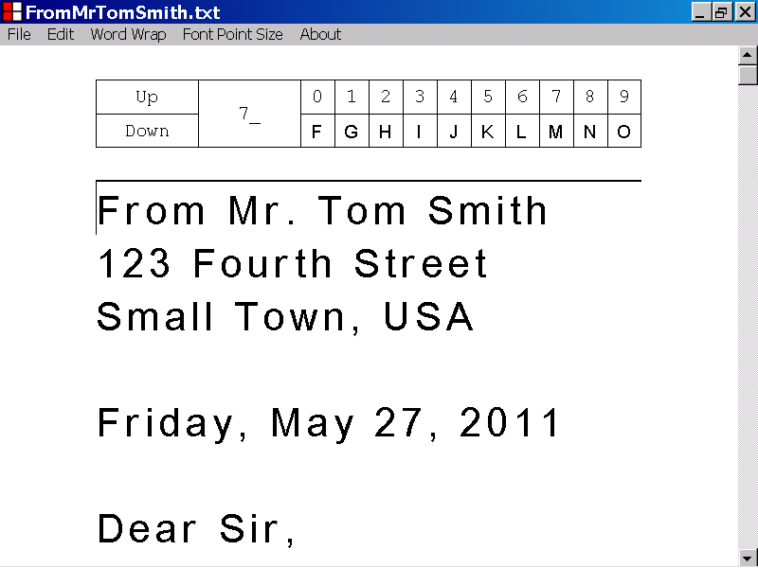

In the illustration below, keyboard focus has been set to the Letter Box control, by left clicking the Down button of the Letter Box control.

The scrolling capabilities of the Down button have been triggered.

The Down button has become the selected button of the Letter Box control, and keyboard input will now be directed to the capabilities of the Down button.
The Down button is the selected button of the Letter Box control.
The Letter Box control has been scrolled downward.
The Letter Box control has keyboard focus.
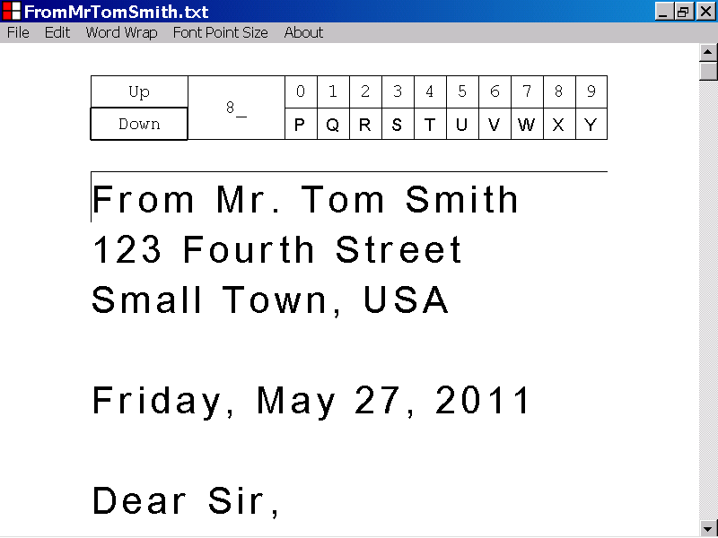

In the illustration below, none of the buttons of the Letter Box control display a double thickness border, which indicates that the Letter Box control does not have keyboard focus.

You can set focus to the Letter Box control, by left clicking the Line Index label with the mouse device.

If you set keyboard focus to the Letter Box control, by left clicking the Line Index label with the mouse device, the Up button becomes the selected button of the Letter Box control, but the capabilities of the Up button are not triggered.
The Letter Box control does not have keyboard focus.

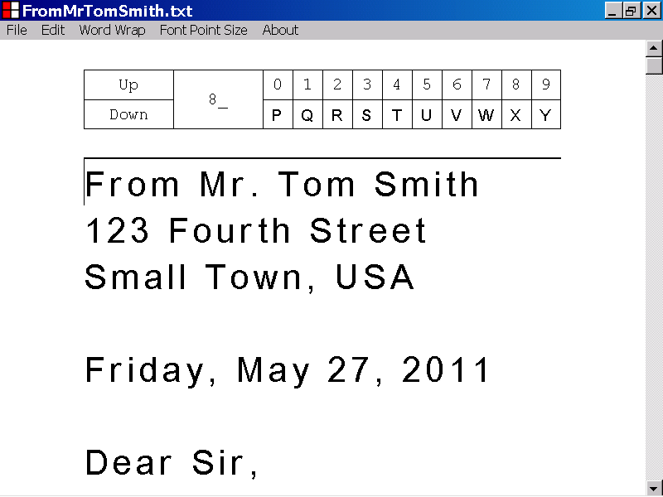

In the illustration below, keyboard focus has been set to the Letter Box control, by left clicking the Line Index label of the Letter Box control.

The Up button has become the selected button of the Letter Box control and keyboard input will now be directed to the capabilities of the Up button.

The scrolling capabilities of the Up button have not been triggered.
The Up button is the selected button of the Letter Box control.
The location of the mouse device left click
The Letter Box control has keyboard focus.
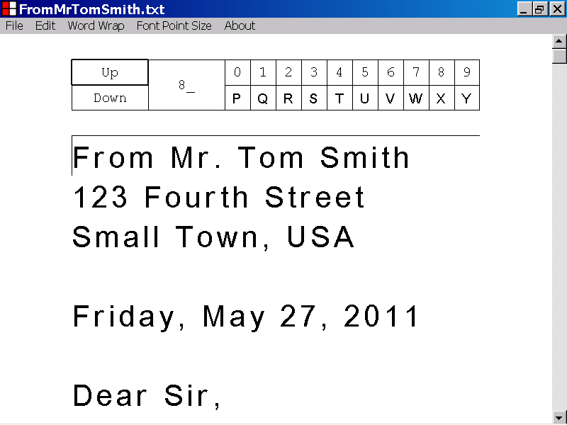

In the illustration below, none of the buttons of the Letter Box control display a double thickness border, which indicates that the Letter Box control does not have keyboard focus.

You can set keyboard focus to the Letter Box control, by left clicking a Letter Display label with the mouse device.

If you set keyboard focus to the Letter Box control, by left clicking a Letter Display label with the mouse device, the Letter Display button directly below the Letter Display label, becomes the selected button of the Letter Box control.

The capabilities of the Letter Display button are not triggered.
The Letter Box control does not have keyboard focus.
In the illustration below, keyboard focus has been set to the Letter Box control, by left clicking the last Letter Display label.

The last Letter Display button, directly below the last Letter Display label, has become the selected button of the Letter Box control and keyboard input will now be directed to the capabilities of the last Letter Display button.

The character insertion capabilities of the last Letter Display button have not been triggered.
The location of the mouse device left click
The Letter Box control has keyboard focus.
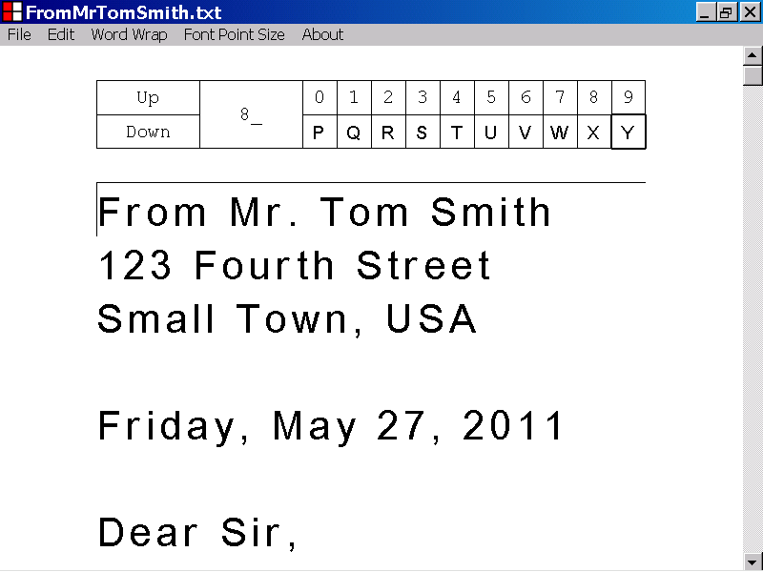
The last Letter Display button is now the selected button of the Letter Box control.

In the illustration below, none of the buttons of the Letter Box control display a double thickness border, which indicates that the Letter Box control does not have keyboard focus.

You can set keyboard focus to the Letter Box control, by left clicking a Letter Display button with the mouse device.

If you set keyboard focus to the Letter Box control, by left clicking a Letter Display button with the mouse device, the capabilities of the Letter Display button are triggered, and the Letter Display button becomes the selected button of the Letter Box control.
The Letter Box control does not have keyboard focus.

In the illustration below, keyboard focus has been set to the Letter Box control, by left clicking the sixth Letter Display button of the Letter Box control.

The character insertion capabilities of the sixth Letter Display button have been triggered.

The sixth Letter Display button has become the selected button of the Letter Box control, and keyboard input will now be directed to the capabilities of the sixth Letter Display button.
The Letter Box control has keyboard focus.
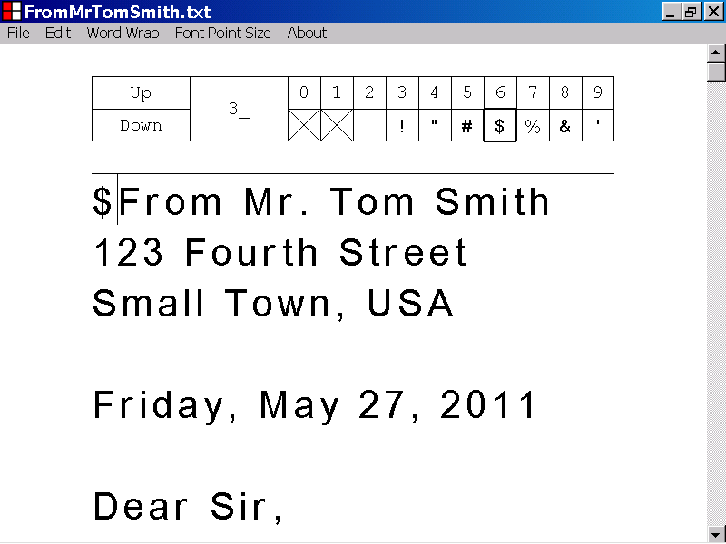
A character has been inserted into the text document.
The sixth Letter Display button is now the selected button of the Letter Box control.

15) How to insert a character into a text document, by directing keyboard input to the Letter Box control.

This section of the documentation provides information about how to insert a character into a text document, by directing keyboard input to the Letter Box control.

You can insert a character into a text document, by directing keyboard input to the Letter Box control, using one of the techniques, described below.

In order to insert a character into a text document, by directing keyboard input to the Letter Box control, the Letter Box control must have keyboard focus, and one of the Letter Display buttons must be the selected button of the Letter Box control.

If the Letter Box control does not have keyboard focus, or none of the Letter Display buttons are the selected button of the Letter Box control, you can set keyboard focus to the Letter Box control, and make one of the Letter Display buttons, the selected button of the Letter Box control, by left clicking, with the mouse, the Letter Display label, directly above the Letter Display button.

In the illustration below, the Letter Box control has keyboard focus, and the sixth Letter Display button is the selected button of the Letter Box control.

If the Letter Box control has keyboard focus, and one of the Letter Display buttons is the selected button of the Letter Box control, you can insert the character, displayed by the Letter Display button, into the text document, by pressing the Enter key.

The character, inserted, will be positioned just after the caret.
The Letter Box control has keyboard focus.
The sixth Letter Display button is the selected button of the Letter Box control.
The caret
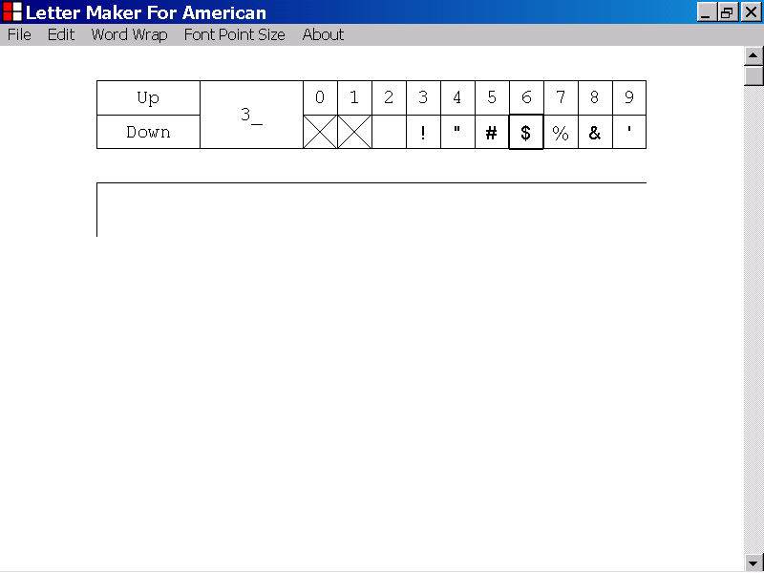

In the illustration below, the character displayed by the sixth Letter Display button, the “dollar sign” character, has been inserted into the text document, by pressing the Enter key.

The character has been positioned just after the old position of the caret.
The old position of the caret
The “dollar sign” character , “$”, has been inserted into the text document.
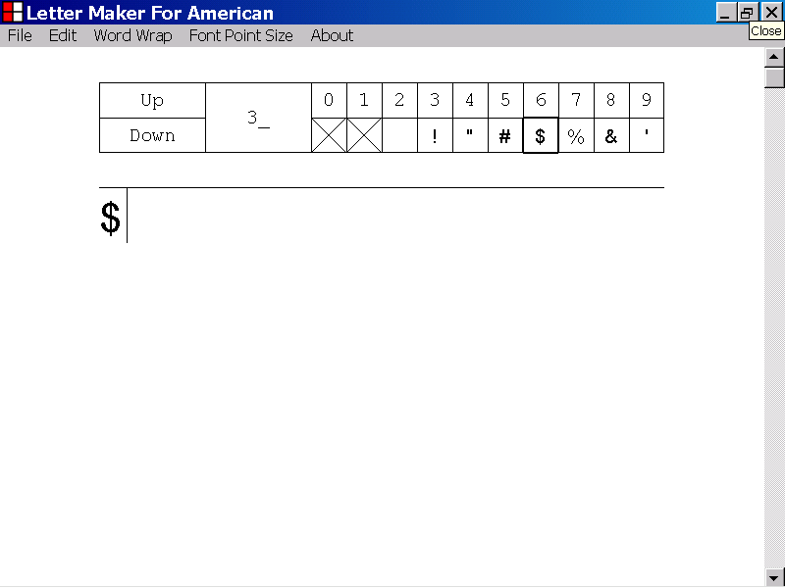

In the illustration below, the Letter Box control has keyboard focus, and the fifth Letter Display button is the selected button of the Letter Box control.

If the Letter Box control has keyboard focus, and one of the Letter Display buttons is the selected button of the Letter Box control, you can insert the character displayed by that Letter Display button, into the text document by pressing the Spacebar.

The character, inserted, will be positioned just after the caret.
The Letter Box control has keyboard focus.
The caret
The fifth Letter Display button is the selected button of the Letter Box control.
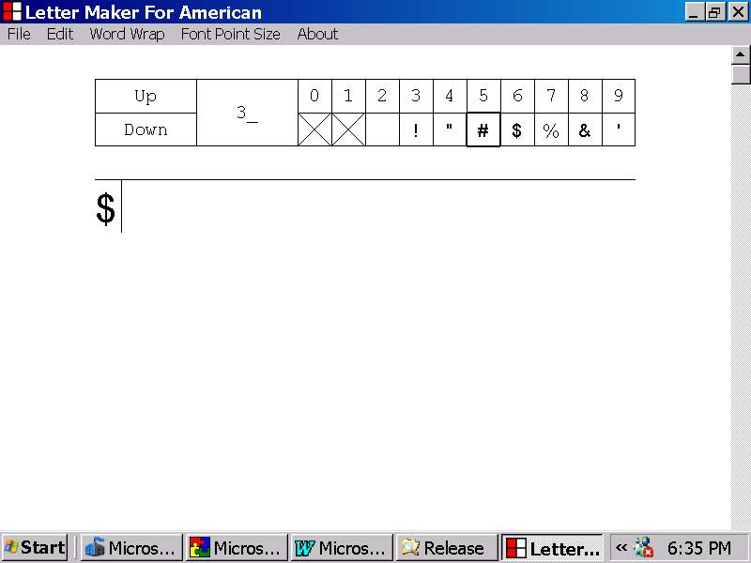

In the illustration below, the character displayed by the selected Letter Display button, the “number sign” character, has been inserted into the text document, by pressing the Spacebar.

The character has been positioned just after the old position of the caret.
The “number sign” character, “#”, has been inserted into the text document.
The old position of the caret
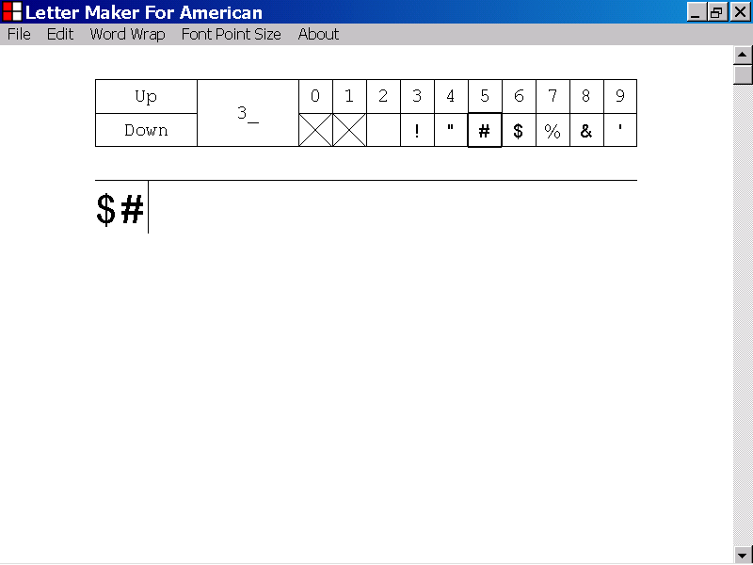

16) How to insert a character into a text document, by directing mouse device input to the Letter Box control

This section of the documentation, provides information about how to insert a character into a text document by directing mouse device input to the Letter Box control.

In the illustration below, a new document is displayed in the Text Box control of the Letter Maker For American program.

The position of the caret is identified with a label.
The caret

You can insert the character displayed by a Letter Display button of the Letter Box control, into the current text document, by left clicking the Letter Display button with the mouse device.

The character, inserted, will be positioned just after the caret.

In the illustration below, the character displayed by the sixth Letter Display button, the “dollar sign” character, has been inserted into the text document, by left clicking the sixth Letter Display button, with the mouse device.

The character has been positioned just after the old position of the caret.
The old position of the caret
The location of the mouse device left click
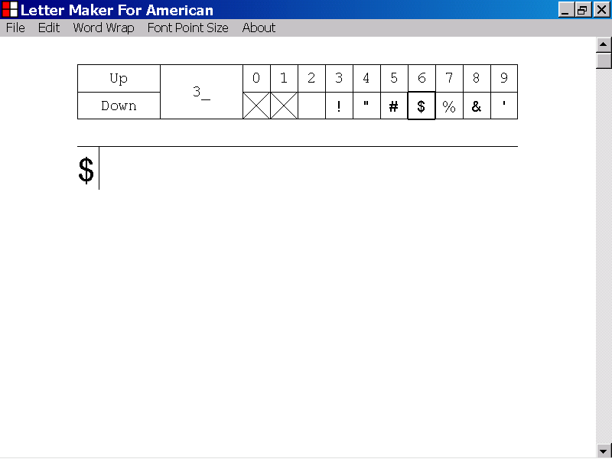
The “dollar sign” character has been inserted into the text document.

In the illustration below, a text document is displayed in the Text Box control of the Letter Maker For American program.

The position of the caret is identified with a label.
The caret

In the illustration below, the character displayed by the fifth Letter Display button, the “number sign” character, has been inserted into the text document, by left clicking the fifth Letter Display button with the mouse device.

The character has been positioned just after the old position of the caret.
The location of the mouse device left click
The “number sign” character, “#”, has been inserted into the text document.
The old position of the caret

